

**FASHION SHOP ONLINE**

**Software Design Document**

– Hanoi, May 2021 –

**Table of Contents**

**I. Overview** **9**

1. Code Packages/Namespaces 9

2. Coding Conventions 10

**II. Code Designs** **10**

1. Public/Home Page 10

a. Class Diagram 10

b. Class Specifications 11

XYZ Class 11

c. Sequence Diagram(s) 11

d. Database queries 11

2. Public/Blogs List 12

a. Class Diagram 12

b. Class Specifications 12

XYZ Class 12

c. Sequence Diagram(s) 13

d. Database queries 13

3. Public/Blog Details 14

a. Class Diagram 14

b. Class Specifications 14

XYZ Class 14

c. Sequence Diagram(s) 15

d. Database queries 15

4. Public/Products List 16

a. Class Diagram 16

b. Class Specifications 16

c. Sequence Diagram(s) 17

d. Database queries 17

5. Public/Product Details 18

a. Class Diagram 18

b. Class Specifications 18

XYZ Class 18

c. Sequence Diagram(s) 18

d. Database queries 18

6. Public/Cart Details 18

a. Class Diagram 18

b. Class Specifications 19

XYZ Class 19

c. Sequence Diagram(s) 19

d. Database queries 19

7. Public/Cart Contact 20

a. Class Diagram 20

b. Class Specifications 20

XYZ Class 20

c. Sequence Diagram(s) 21

d. Database queries 21

8. Public/Cart Completion 22

a. Class Diagram 22

b. Class Specifications 22

XYZ Class 22

c. Sequence Diagram(s) 23

d. Database queries 23

9. Public/Feedback 23

a. Class Diagram 24

b. Class Specifications 24

XYZ Class 24

c. Sequence Diagram(s) 25

d. Database queries 25

11. Common/Login 26

a. Class Diagram 26

b. Class Specifications 26

c. Sequence Diagram(s) 27

d. Database queries 27

6. Common/Register 27

a. Class Diagram 28

b. Class Specifications 28

c. Sequence Diagram(s) 28

d. Database queries 29

12. Common/Reset Password 29

a. Class Diagram 29

c. Sequence Diagram(s) 30

d. Database queries 30

13. Common/Change Password 31

a. Class Diagram 31

b. Class Specifications 31

c. Sequence Diagram(s) 32

d. Database queries 32

14. Common/User Profile 32

a. Class Diagram 33

b. Class Specifications 33

c. Sequence Diagram(s) 33

d. Database queries 34

15. Common/User Authorization 35

a. Class Diagram 35

b. Class Specifications 35

c. Sequence Diagram(s) 36

d. Database queries 36

16. Customer/My Orders 36

a. Class Diagram 37

b. Class Specifications 37

XYZ Class 37

c. Sequence Diagram(s) 37

d. Database queries 38

17. Customer/Order Information 39

a. Class Diagram 39

b. Class Specifications 39

XYZ Class 39

c. Sequence Diagram(s) 39

d. Database queries 40

18. Marketing/MKT Dashboard 41

a. Class Diagram 41

b. Class Specifications 41

XYZ Class 41

c. Sequence Diagram(s) 41

d. Database queries 42

19. Marketing/Posts List 42

a. Class Diagram 43

b. Class Specifications 43

XYZ Class 43

c. Sequence Diagram(s) 43

d. Database queries 44

20. Marketing/Post Details 45

a. Class Diagram 45

b. Class Specifications 45

XYZ Class 45

c. Sequence Diagram(s) 46

d. Database queries 46

21. Marketing/Sliders List 47

a. Class Diagram 47

b. Class Specifications 47

XYZ Class 47

c. Sequence Diagram(s) 47

d. Database queries 48

22. Marketing/Slider Details 49

a. Class Diagram 49

b. Class Specifications 49

XYZ Class 49

c. Sequence Diagram(s) 49

d. Database queries 50

23. Marketing/Products List 50

a. Class Diagram 50

b. Class Specifications 50

c. Sequence Diagram(s) 51

d. Database queries 51

24. Marketing/Product Details 52

a. Class Diagram 52

b. Class Specifications 52

XYZ Class 52

c. Sequence Diagram(s) 53

d. Database queries 53

25. Marketing/Customers List 55

a. Class Diagram 55

b. Class Specifications 55

c. Sequence Diagram(s) 55

d. Database queries 56

26. Marketing/Customer Details 57

a. Class Diagram 57

b. Class Specifications 57

c. Sequence Diagram(s) 57

d. Database queries 58

27. Marketing/Feedbacks List 59

a. Class Diagram 59

b. Class Specifications 59

XYZ Class 59

c. Sequence Diagram(s) 59

d. Database queries 60

28. Marketing/Feedback Details 60

a. Class Diagram 60

b. Class Specifications 60

XYZ Class 60

c. Sequence Diagram(s) 60

d. Database queries 61

29. Sale/Sale Dashboard 61

a. Class Diagram 62

b. Class Specifications 62

XYZ Class 62

c. Sequence Diagram(s) 63

d. Database queries 63

30. Sale/Orders List 64

a. Class Diagram 65

b. Class Specifications 65

XYZ Class 65

c. Sequence Diagram(s) 65

d. Database queries 66

31. Sale/Order Details 66

a. Class Diagram 67

b. Class Specifications 67

XYZ Class 67

c. Sequence Diagram(s) 67

d. Database queries 68

32. Admin/Admin Dashboard 69

a. Class Diagram 69

b. Class Specifications 69

XYZ Class 69

c. Sequence Diagram(s) 69

d. Database queries 70

33. Admin/Users List 70

a. Class Diagram 71

b. Class Specifications 71

XYZ Class 71

c. Sequence Diagram(s) 71

d. Database queries 72

34. Admin/User Details 72

a. Class Diagram 73

b. Class Specifications 73

XYZ Class 73

c. Sequence Diagram(s) 73

d. Database queries 73

35. Admin/Settings List 73

a. Class Diagram 73

b. Class Specifications 74

c. Sequence Diagram(s) 74

d. Database queries 75

36. Admin/Setting Details 75

a. Class Diagram 75

b. Class Specifications 75

XYZ Class 75

c. Sequence Diagram(s) 75

d. Database queries 76

37. Public/Blog List 76

a. Class Diagram 77

b. Class Specifications 77

XYZ Class 77

c. Sequence Diagram(s) 77

d. Database queries 78

38. Public/ Blog Details 78

a. Class Diagram 79

b. Class Specifications 79

XYZ Class 79

c. Sequence Diagram(s) 80

d. Database queries 80

**III. Database Design** **80**

1. Database Schema 81

2. Table Description 81

# I. Overview

## 1. Code Packages/Namespaces

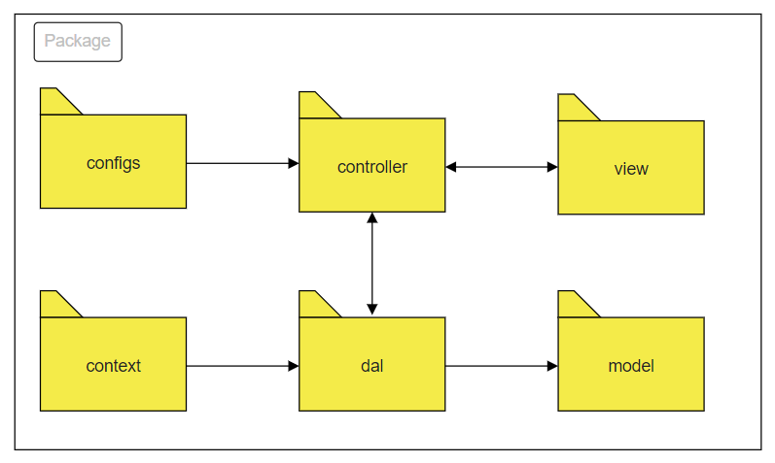

***Package descriptions & package class naming conventions***

| **No** | **Package** | **Description** |
| --- | --- | --- |
| *01* | *controller* | *Acts as a go-between for the service layer and the Front-end, passing on different input requests*  *<Class naming convention>* |
| *02* | *dal* | *This component is used to get data directly FROM the database*  *<Class naming convention>* |
| *03* | *configs* | *This component helps define configuration*  *<Class naming convention>* |
| *04* | *context* | *This component helps connect database*  *<Class naming convention>* |
| *05* | *model* | *This component includes interfaces used to receive data retrieved FROM the database and classes used to receive data*  *<Class naming convention>* |
| *05* | *view* | *This component display front-end*  *<Class naming convention>* |

## 2. Coding Conventions

# II. Code Designs

## 1. Public/Home Page

### a. Class Diagram

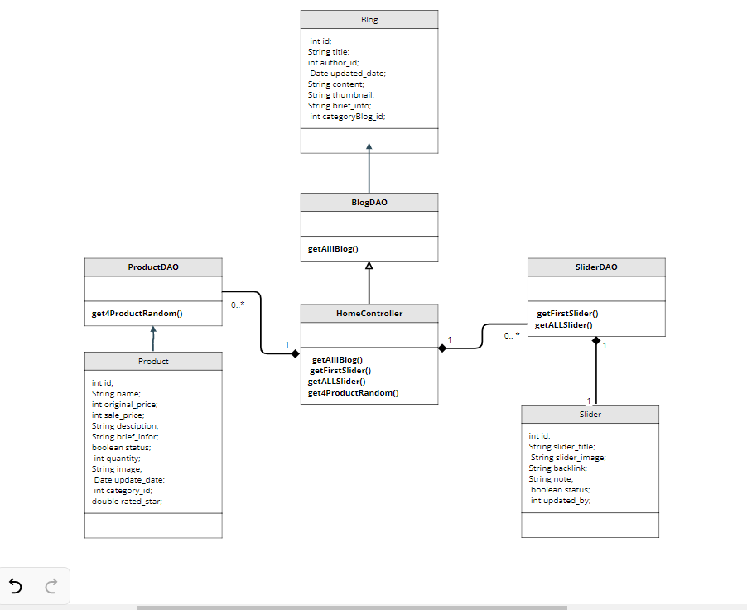

### b. Class Specifications

#### XYZ Class

| **No** | **Method** | **Description** |
| --- | --- | --- |
| *01* | *getAllIBlog()* | *get all property in Blog* |
| *02* | *getFirstSlider()* | *get all property in slider first* |
| *03* | *getALLSlider()* | *get all property in slider* |
| *04* | *get4ProductRandom()* | *get 4 product random from products* |
|  |  |  |

### c. Sequence Diagram(s)

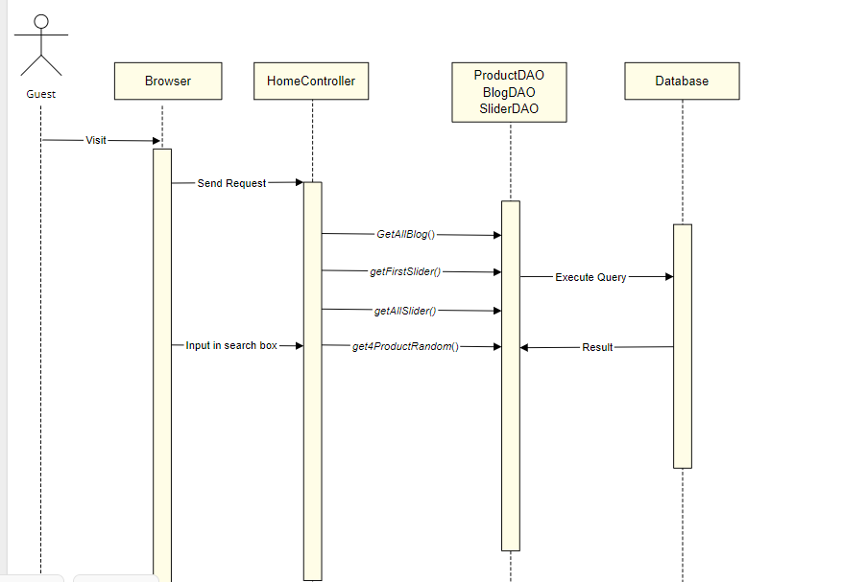

### d. Database queries

SELECT top 1 * FROM [dbo].[Slider]

SELECT * FROM [dbo].[Slider]

Select * from Blog

Select top 4 * from Product ORDER BY NEWID()

## 2. Public/Blogs List

### a. Class Diagram

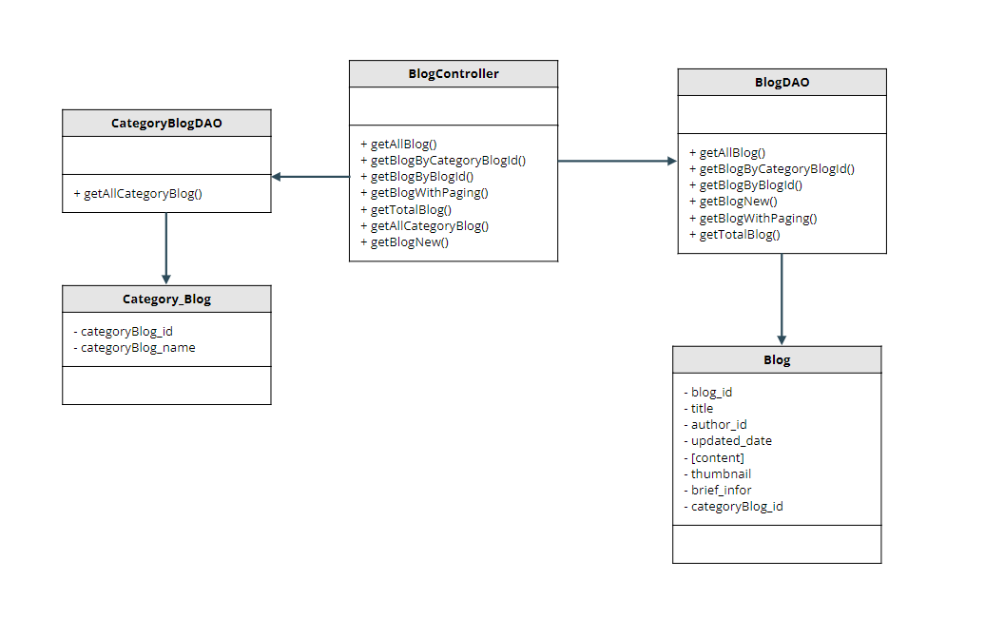

### b. Class Specifications

#### XYZ Class

| **No** | **Method** | **Description** |
| --- | --- | --- |
| *01* | *getAllBlog* | *get all blog* |
| *02* | *getBlogByCategoryBlogId* | *get blog by category id* |
| *03* | *getBlogByBlogId* | *get blog by blog id* |
| *04* | *getBlogWithPaging* | *git blog with paging* |
| *05* | *getTotalBlog* | *get total blog* |
| *06* | *getAllCategoryBlog* | *get all category blog* |
| *07* | *getBlogNew* | *get blog new* |

### c. Sequence Diagram(s)

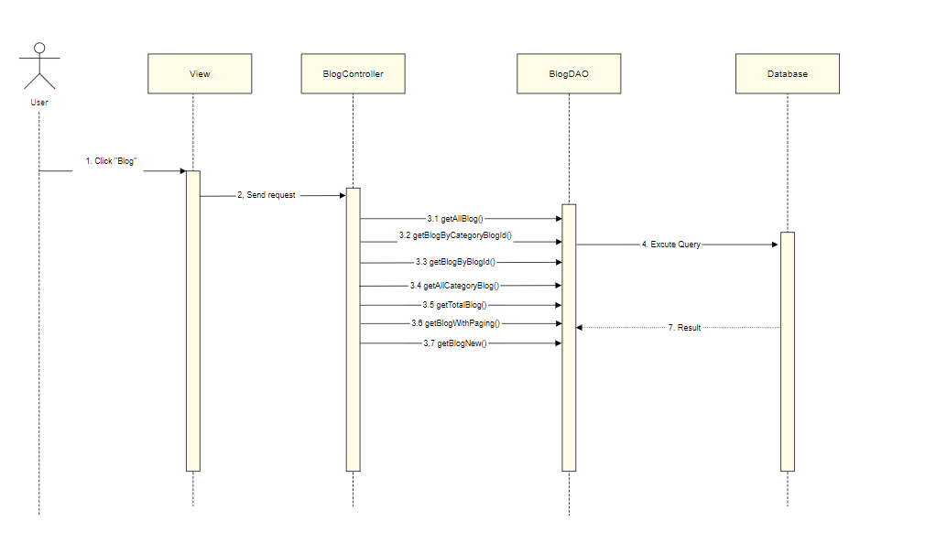

### d. Database queries

Select top 2 * from Blog order by newid()

Select * from Blog where categoryBlog_id = ?

Select * from Blog where blog_id = ?

select top 1 * from Blog order by updated_date desc

Select count(*) from Blog "

+ "where categoryBlog_id " + categoryId + " and status = 1 and title like N'%" + searchKey + "%'\n

select * from Blog\n"

+ "where categoryBlog_id " + categoryId + " and status = 1 and title like N'%" + searchKey + "%'\n"

+ " order by " + value + " " + type + " offset (?-1)*? row fetch next ? row only\

Select * from Category_Blog and status = 1

## 3. Public/Blog Details

### a. Class Diagram

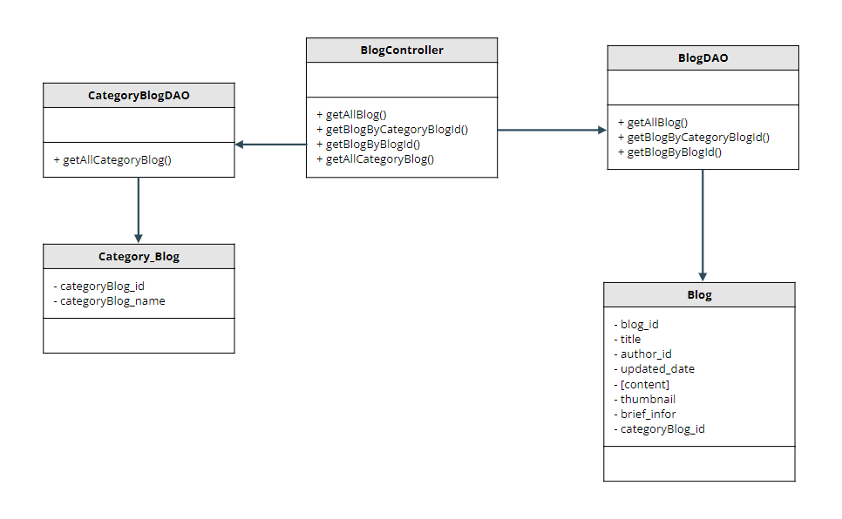

### b. Class Specifications

#### XYZ Class

#### 

| **No** | **Method** | **Description** |
| --- | --- | --- |
| *01* | *getAllBlog* | *get all blog* |
| *02* | *getBlogByCategoryBlogId* | *get blog by category id* |
| *03* | *getBlogByBlogId* | *get blog by blog id* |
| *04* | *getAllCategoryBlog* | *get all category blog* |

### 

### c. Sequence Diagram(s)

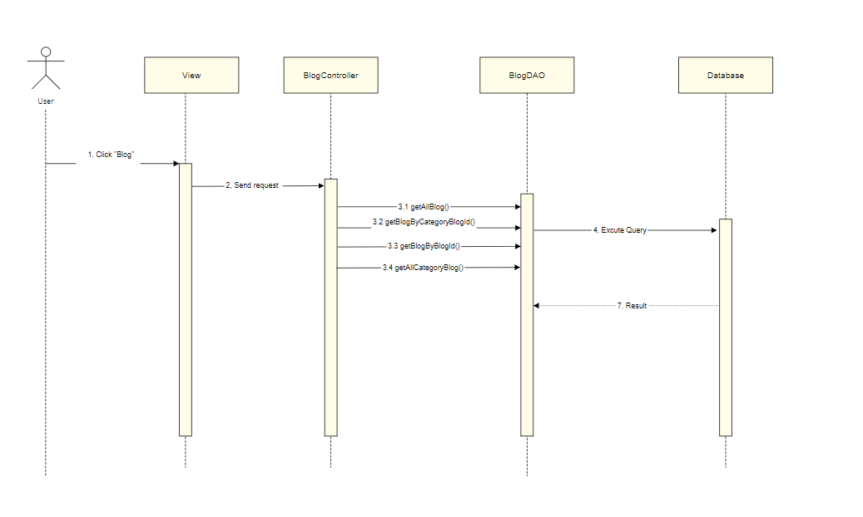

### d. Database queries

Select top 2 * from Blog order by newid()

Select * from Blog where categoryBlog_id = ?

Select * from Blog where blog_id = ?

Select * from Category_Blog and status = 1

## 4. Public/Products List

### a. Class Diagram

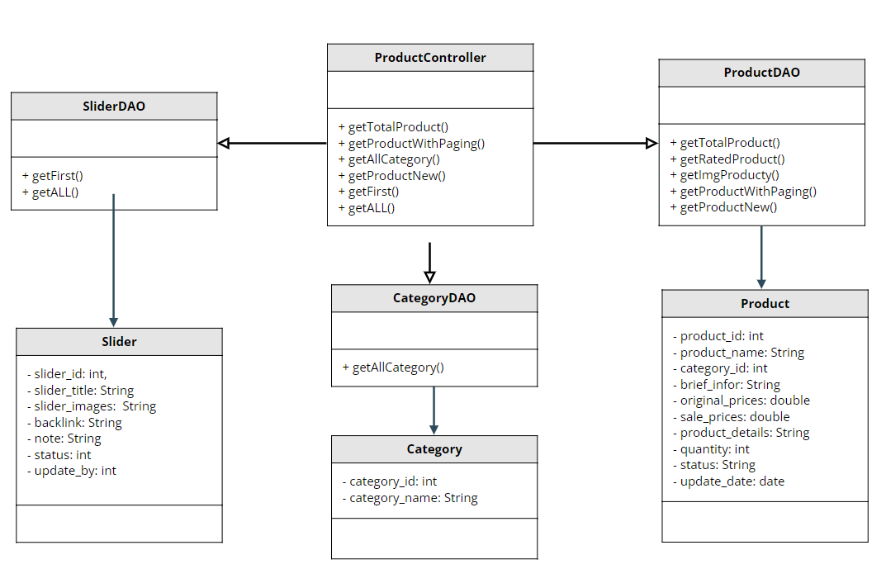

### b. Class Specifications

| **No** | **Method** | **Description** |
| --- | --- | --- |
| *01* | *getTotalProduct()* | *Get the amount of all products* |
| *02* | *getProductWithPaging()* | *Get all product pagination in database* |
| *03* | *getAllCategory()* | *Get all category in database* |
| *04* | *getProductNew()* | *Get a product latest post* |
| *05* | *getFirst()* | *Get first slider in database* |
| *06* | *getAll()* | *Get all slider in database* |
| *07* | *getRatedProduct()* | *Get rated vote for the product* |
| *08* | *getImgProduct()* | *Get image for the product* |

### c. Sequence Diagram(s)

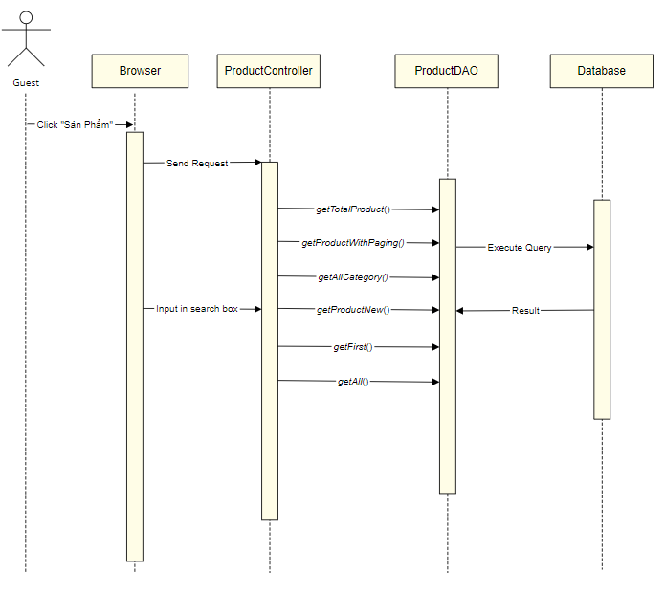

### d. Database queries

* Select count(product_id) from Product where category_id "+categoryId+" and product_name like N'%"+searchKey+"%'
* Select * from Product\n"

+ "where category_id "+categoryId+" and product_name like N'%"+searchKey+"%'\n"

+ " order by "+value+" "+type+" offset (?-1)*? row fetch next ? row only

* Select * from Category
* Select top 1 * from Product order by update_date desc
* SELECT top 1 * FROM [dbo].[Slider]
* SELECT * FROM [dbo].[Slider]

## 5. Public/Product Details

### a. Class Diagram

### b. Class Specifications

#### XYZ Class

| **No** | **Method** | **Description** |
| --- | --- | --- |
| *01* |  |  |
| *02* |  |  |
| *03* |  |  |
| *04* |  |  |

### c. Sequence Diagram(s)

### d. Database queries

## 6. Public/Cart Details

### a. Class Diagram

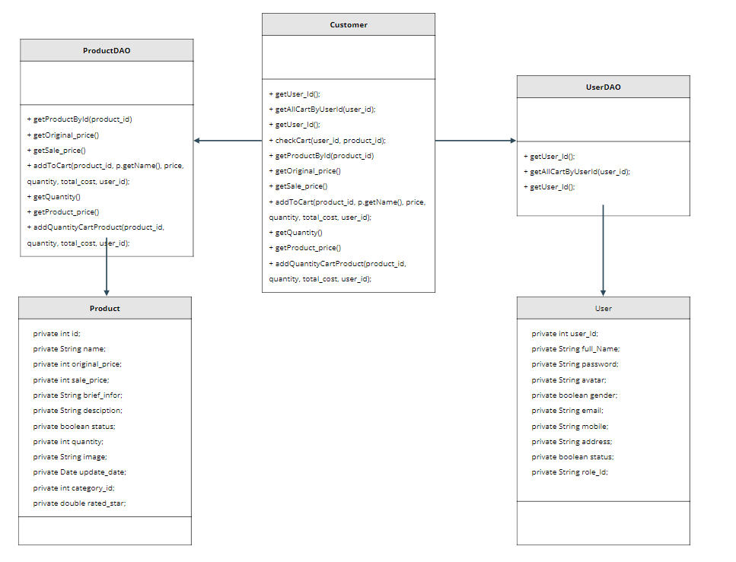

### b. Class Specifications

#### XYZ Class

| **No** | **Method** | **Description** |
| --- | --- | --- |
| *01* | *getAllCartByUserId(user_id);* | *get all product by userID in Database* |
| *02* | *getUser_Id();* | *get userID in User Database* |
| *03* | *checkCart(user_id, product_id);* | *Check product in cart by user_id in user and product_Id in product* |
| *04* | *getProductById(product_id)* | *get Product by Id_producrt in the product modal* |
| *05* | *getOriginal_price()* | *get original_price in product in database* |
| *06* | *getSale_price()* | *get sale_price in product in Database* |
| *07* | *addToCart(product_id, p.getName(), price, quantity, total_cost, user_id);* | *save new product in database cart* |
| *08* | *getQuantity()* | *get number at table product in database* |
| *09* | *getProduct_price()* | *Last value at table product in database* |
| *10* | *addQuantityCartProduct(product_id, quantity, total_cost, user_id);* | *add new number at table product to database* |

### c. Sequence Diagram(s)

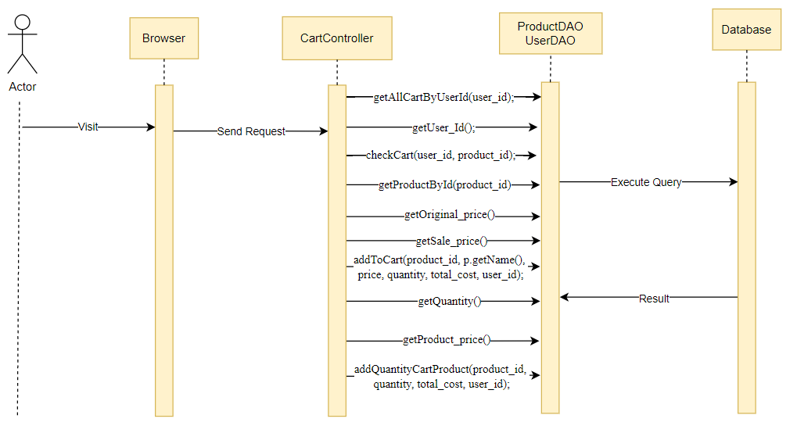

### d. Database queries

UPDATE [dbo].[Cart]\n"

+ " SET [quantity] = ? \n"

+ " ,[total_cost] = ? \n"

+ " WHERE [product_id] = ? and [user_id] = ?"

## 7. Public/Cart Contact

### a. Class Diagram

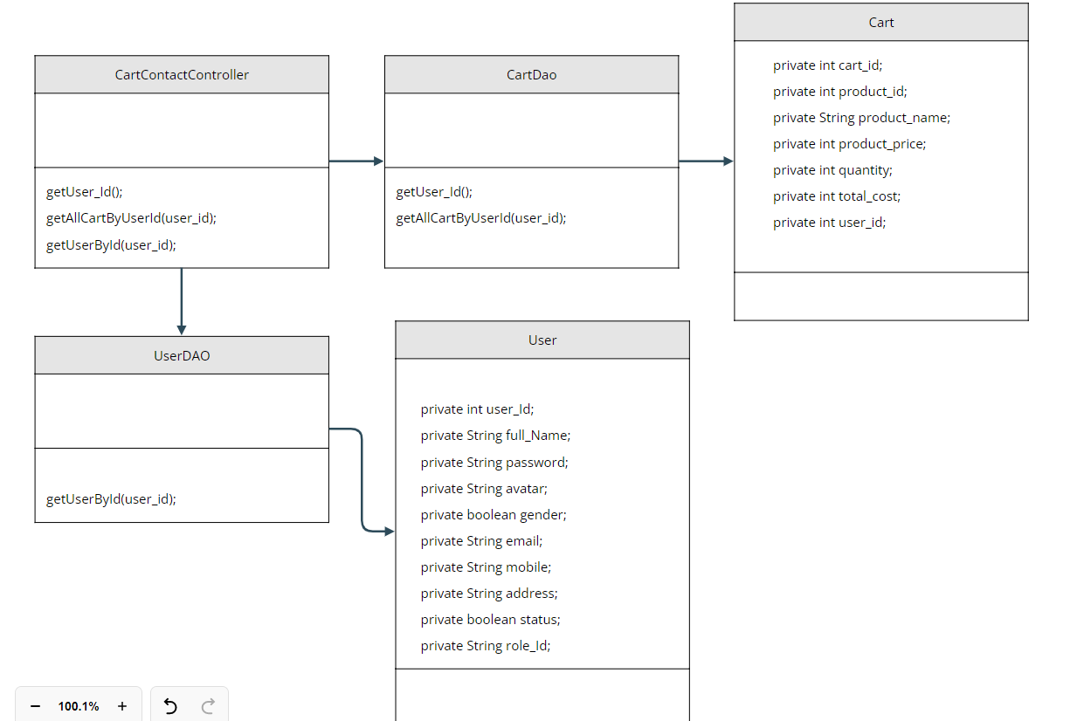

### b. Class Specifications

#### XYZ Class

| **No** | **Method** | **Description** |
| --- | --- | --- |
| *01* | *getUser_Id();* | *get User by id in table cart database* |
| *02* | *getAllCartByUserId(user_id);* | *get all carrt by User in table cart database* |
| *03* | *getUserById(user_id);* | *get User by usser in table database* |

### c. Sequence Diagram(s)

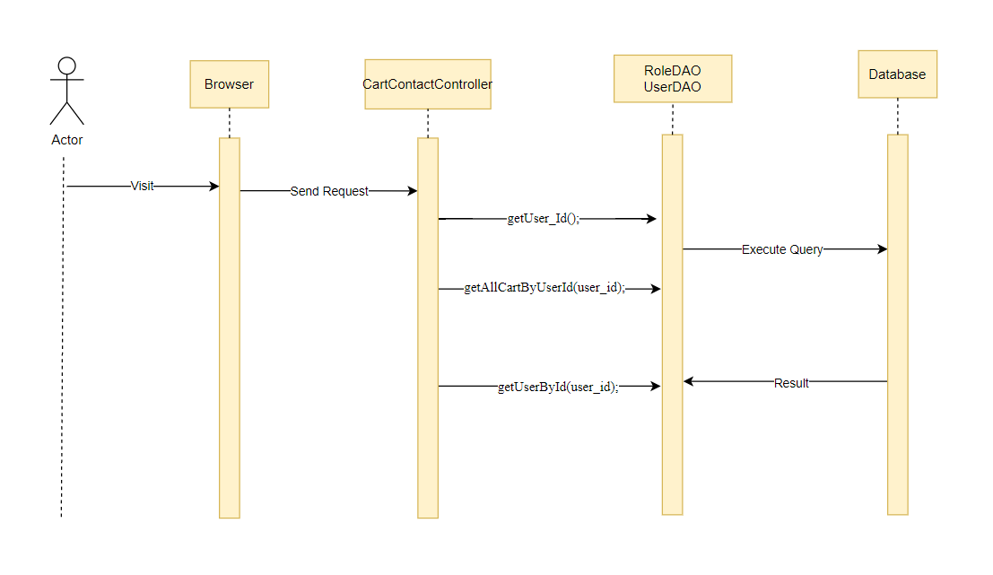

### d. Database queries

select * from Cart where [user_id] = ?

select * from [User] where userId = ?

## 8. Public/Cart Completion

### a. Class Diagram

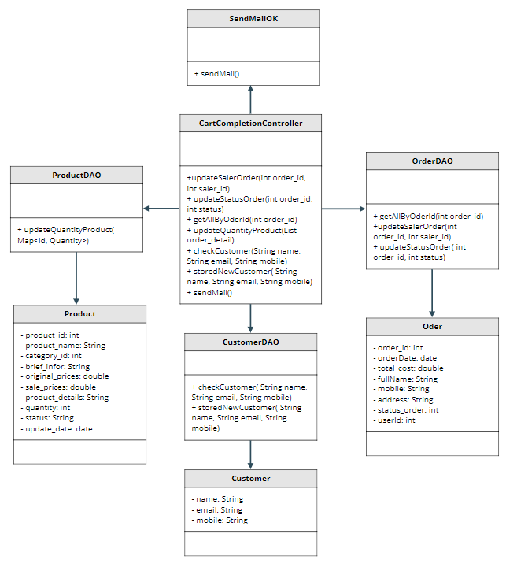

### b. Class Specifications

#### XYZ Class

| **No** | **Method** | **Description** |
| --- | --- | --- |
| *01* | *updateSalerOrder()* | *Update saler random for order selected* |
| *02* | *updateStatusOrder()* | *Update status for order selected* |
| *03* | *getAllByOrderId()* | *Get all information of specific order* |
| *05* | *updateQuantityProduct()* | *Update quantity for each product in order* |
| *06* | *checkCustomer()* | *Check customer existed* |
| *07* | *storedNewCustomer()* | *Stored new customer in the database* |
| *08* | *sendMail()* | *Send mail to customer* |

### c. Sequence Diagram(s)

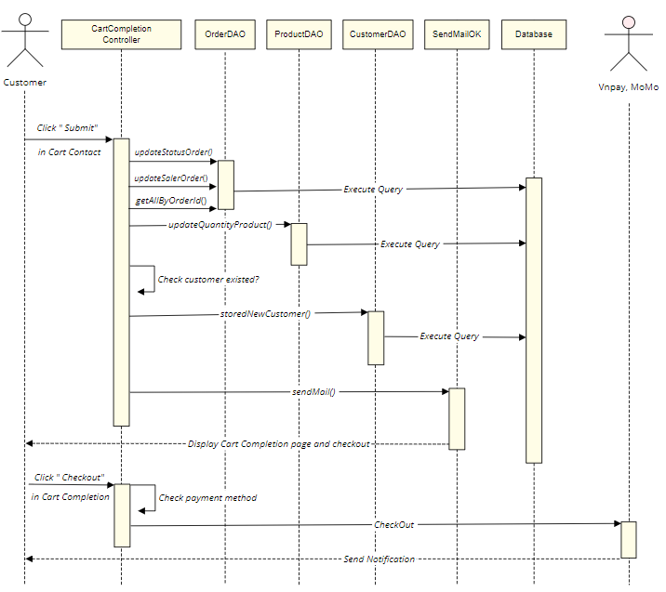

### d. Database queries

* UPDATE [dbo].[Order] SET [saler_id] = ? WHERE order_id = ?
* UPDATE [dbo].[Order] SET [status_order] = ? WHERE order_id = ?
* SELECT * From Order_Detail where order_id = ?
* UPDATE [dbo].[Product] SET [quantity] = (quantity - ? ) WHERE product_id = ?
* SELECT [customer_id], [customer_name], [customer_email], [customer_mobile] FROM [dbo].[Customer] WHERE customer_name = ? and customer_email = ? and customer_mobile = ?
* INSERT INTO [dbo].[Customer] ([customer_name], [customer_email], [customer_mobile]) VALUES (?,?,?)

## 9. Public/Feedback

### a. Class Diagram

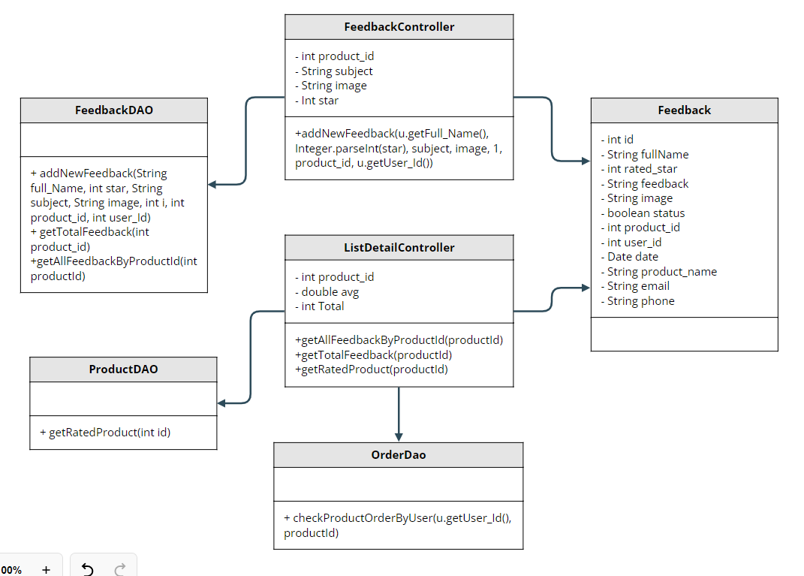

### b. Class Specifications

#### XYZ Class

| **No** | **Method** | **Description** |
| --- | --- | --- |
| *01* | *addNewFeedback(String full_Name, int star, String subject, String image, int i, int product_id, int user_Id)* | *Add new feedback by userid and productid* |
| *02* | *getTotalFeedback(int product_id)* | *Total feedback for show number of all feedback fora product* |
| *03* | *getAllFeedbackByProductId(int productId)* | *Get all feedback for show all feedback for a product* |
| *04* | *getRatedProduct(int id)* | *Avg rated star for a product* |
| *05* | *checkProductOrderByUser(u.getUser_Id(), productId)* | *Check user who purchased the product* |

### c. Sequence Diagram(s)

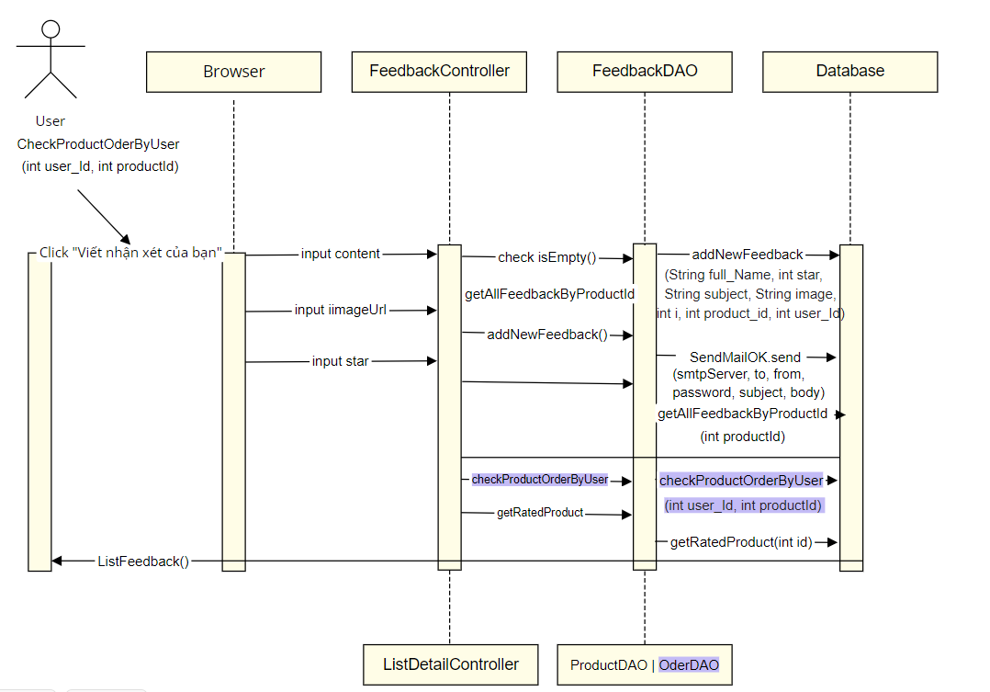

### d. Database queries

-INSERT INTO [dbo].[Feedback]\n"

+ " ([fullName]\n"

+ " ,[rated_star]\n"

+ " ,[feedback]\n"

+ " ,[image]\n"

+ " ,[status]\n"

+ " ,[product_id]\n"

+ " ,[userId])\n"

+ " VALUES\n"

+ " (?,?,?,?,?,?,?)

-select COUNT(feedBack_id) from Feedback where product_id = ?

-checkProductOrderByUser(int user_Id, int productId)

-getAllFeedbackByProductId(int productId)

-select AVG(rated_star) from Feedback where product_id = ?

## 11. Common/Login

### a. Class Diagram

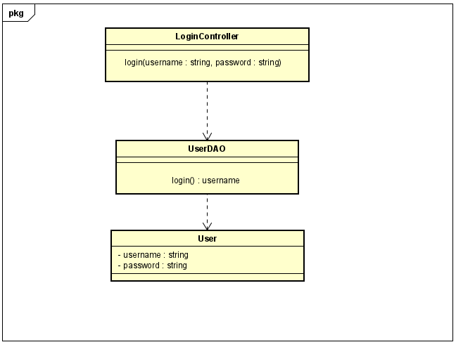

### b. Class Specifications

#### 

| **No** | **Method** | **Description** |
| --- | --- | --- |
| **01** | **login** | **Using to login into the system** |

### c. Sequence Diagram(s)

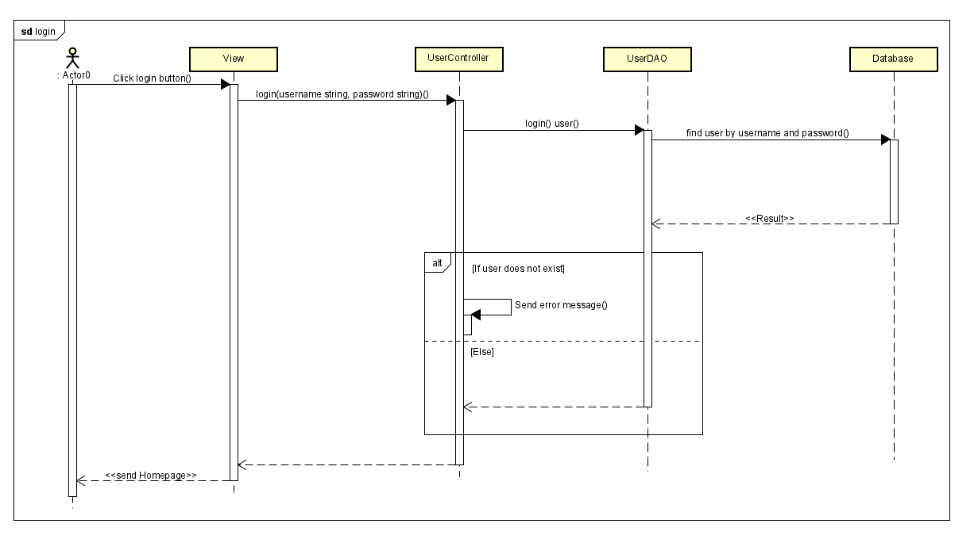

### d. Database queries

**String sql = "SELECT * FROM user where user=? and password=?"**

## 6. Common/Register

### a. Class Diagram

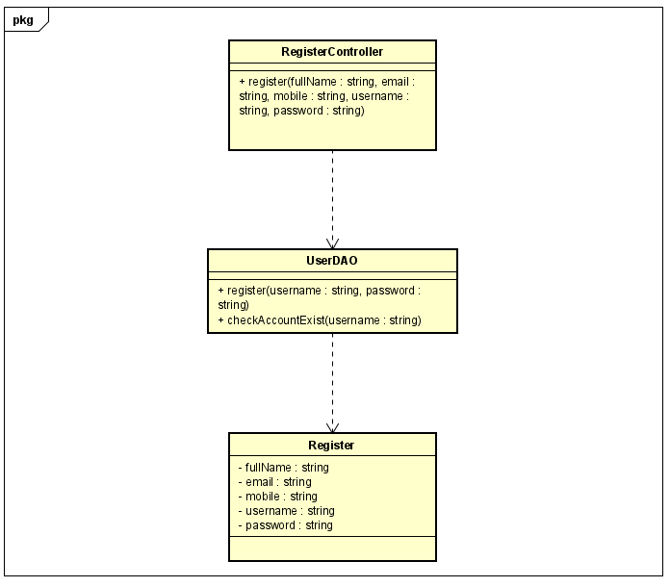

### b. Class Specifications

| **No** | **Method** | **Description** |
| --- | --- | --- |
| **1** | **Register** | **use to create new user** |
| **2** | **checkAccountExist** | **use to check username exist** |

### c. Sequence Diagram(s)

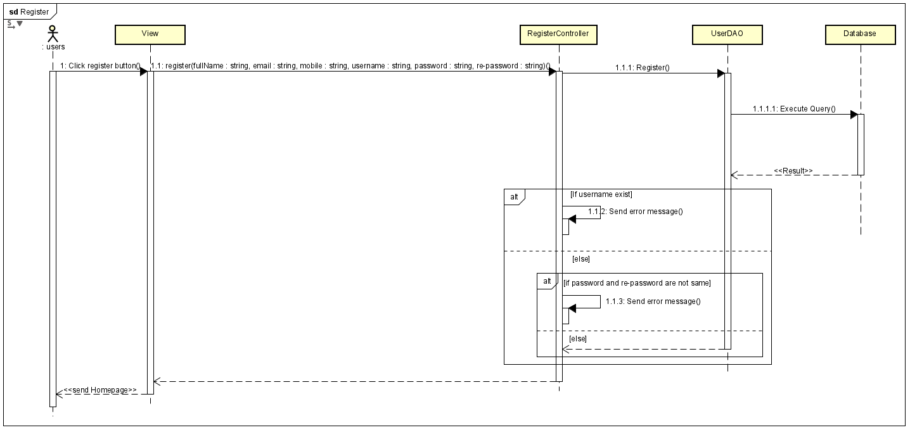

### d. Database queries

* **SELECT * FROM users WHERE username=?**
* **INSERT INTO users (fullName, email, mobile, username, password) VALUES (?, ?, ?, ?, ?)**

## 12. Common/Reset Password

### a. Class Diagram

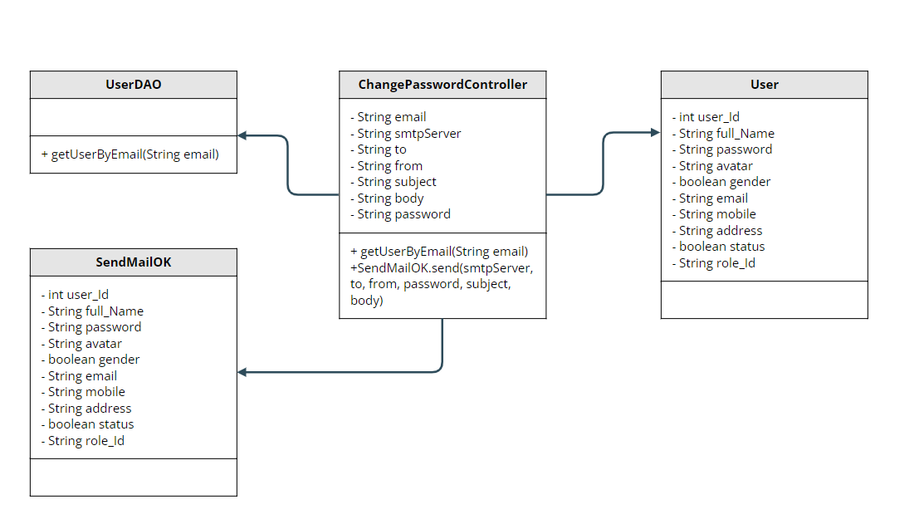**b. Class Specifications**

| **No** | **Method** | **Description** |
| --- | --- | --- |
| *01* | *getUserByEmail(String email)* | *Check email existence* |
| *02* | *SendMailOK.send(smtpServer, to, from, password, subject, body)* | *Send a link that leads the user to the reset password page* |

### c. Sequence Diagram(s)

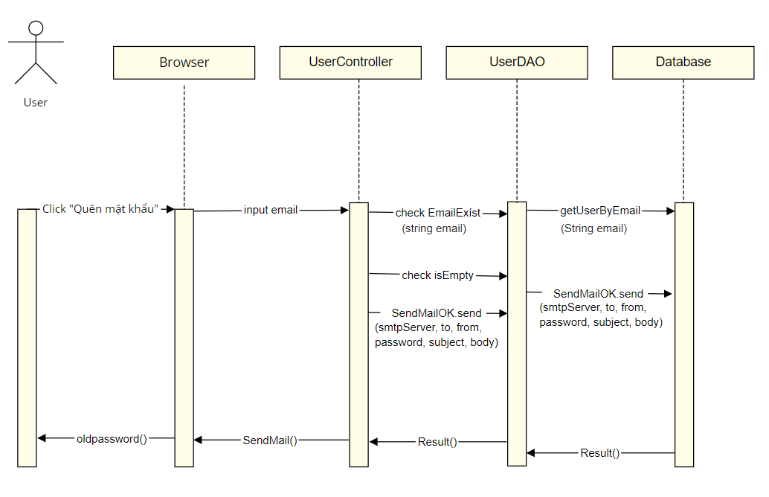

### d. Database queries

* select * from [User] where email = ?

## 13. Common/Change Password

### a. Class Diagram

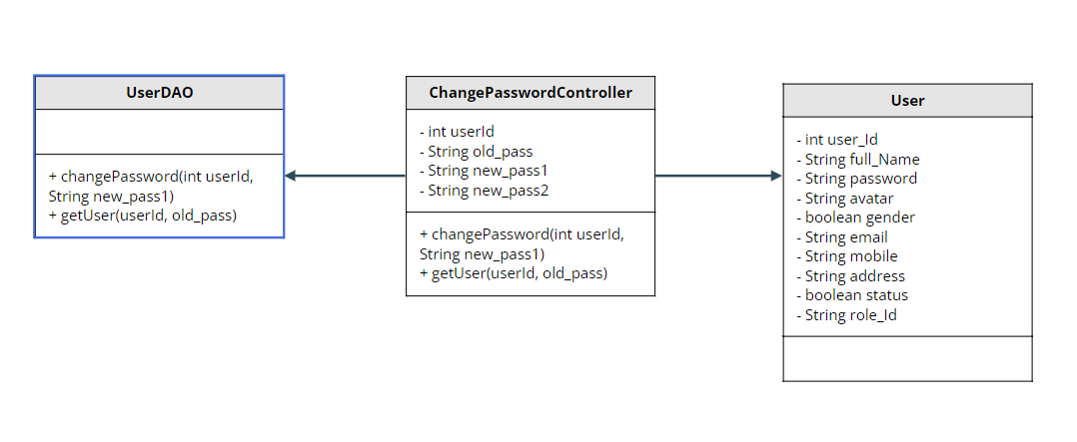

### b. Class Specifications

| **No** | **Method** | **Description** |
| --- | --- | --- |
| *01* | *changePassword(int userId, String new_pass1)* | *Change Password* |
| *02* | *getUser(int userId, String old_pass)* | *Check logged in* |

### c. Sequence Diagram(s)

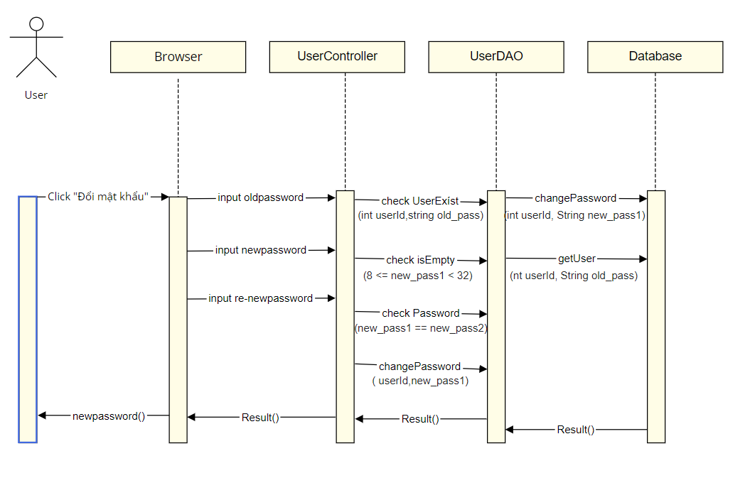

### d. Database queries

* select * from [User] where userId = ? and password = ?
* UPDATE [dbo].[User]\n"

+ " SET \n"

+ " [password] = ?\n"

+ " WHERE userId = ?\n

## 14. Common/User Profile

### a. Class Diagram

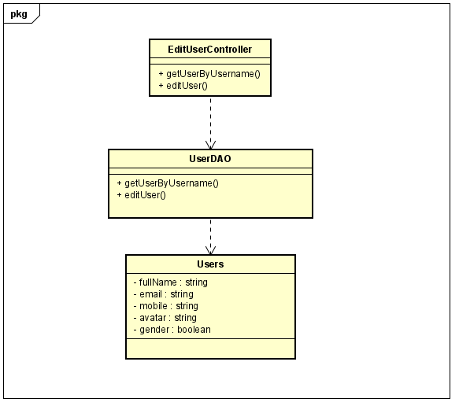

### b. Class Specifications

| **No** | **Method** | **Description** |
| --- | --- | --- |
| **1** | **getUserByUsername()** | **use to find account profile by it’s username** |
| **2** | **editUser()** | **use to update user’s profile** |

### c. Sequence Diagram(s)

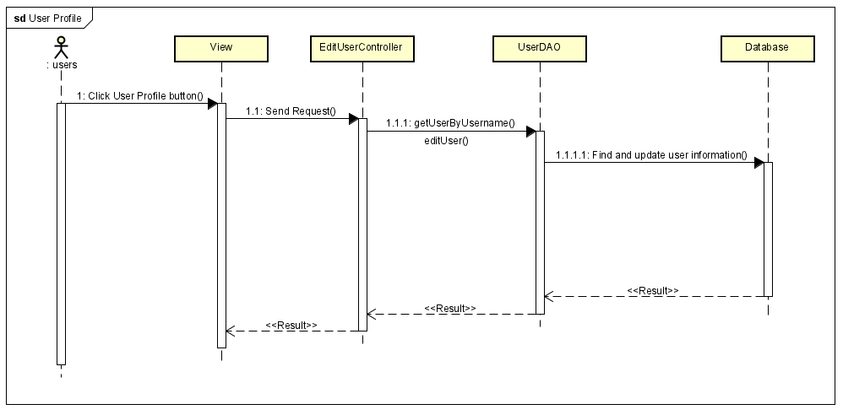

### d. Database queries

* **SELECT fullName, gender, email, mobile, img**

**FROM users**

* **UPDATE users**

**SET fullName = ?, gender = ?, email = ?, mobile = ?, img = ?**

**WHERE username = ?**

## 15. Common/User Authorization

### a. Class Diagram

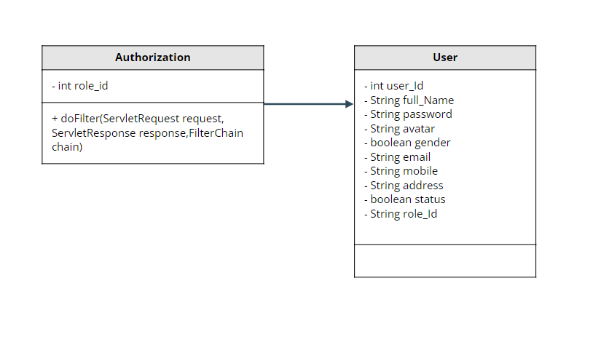

### b. Class Specifications

| **No** | **Method** | **Description** |
| --- | --- | --- |
| *01* | *getRole_Id()* | *Get Role_Id of User* |

### c. Sequence Diagram(s)

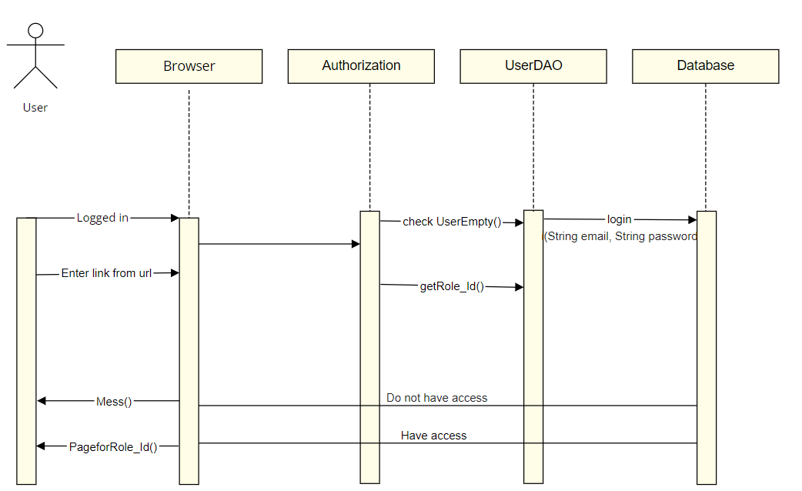

### d. Database queries

-select * from dbo.[User]\n"

+ "where email = ? and [password] = ?

## 16. Customer/My Orders

### a. Class Diagram

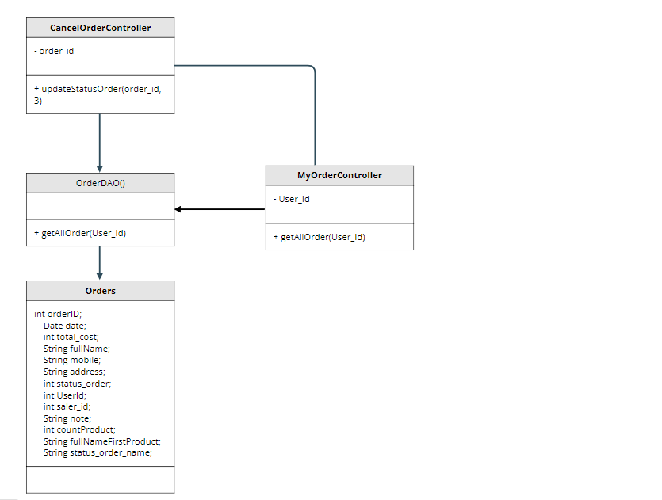

### b. Class Specifications

#### XYZ Class

| **No** | **Method** | **Description** |
| --- | --- | --- |
| *01* | *getAllOrder(User_Id)* | *get customer orders based on id* |
| *02* | *updateStatusOrder(order_id, 3)* | *Update order status to cancel* |

### c. Sequence Diagram(s)

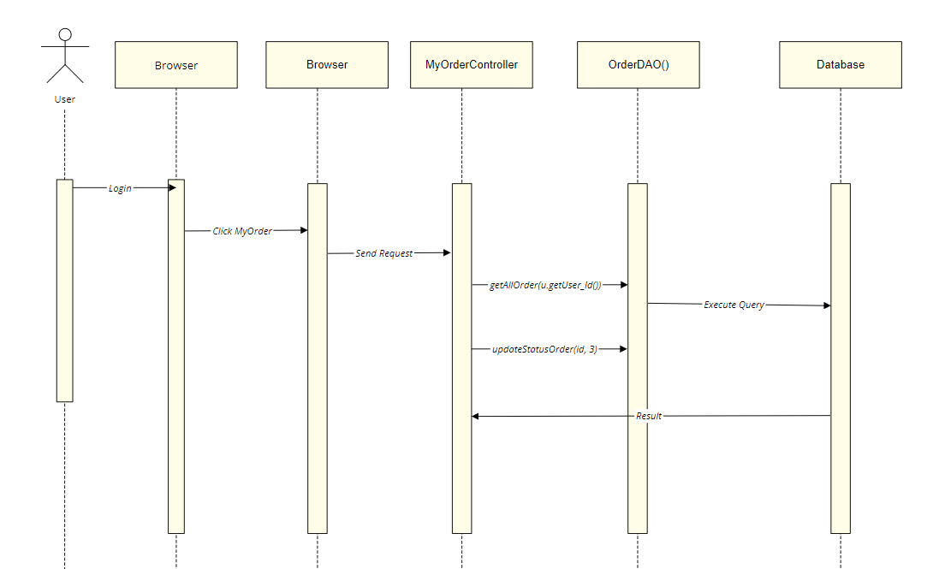

### d. Database queries

UPDATE [dbo].[Order]\n"

+ " SET [status_order] = ?\n"

+ " WHERE order_id = ?

select * from [Order] join Status_Order\n"

+ "on [Order].status_order= Status_Order.status_order_id\n"

+ "where userId = ?

## 17. Customer/Order Information

### a. Class Diagram

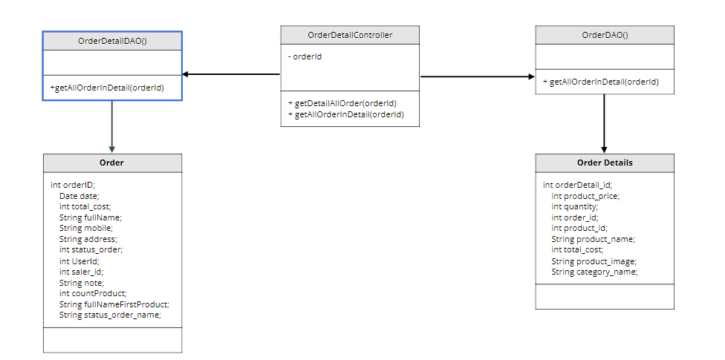

### b. Class Specifications

#### XYZ Class

| **No** | **Method** | **Description** |
| --- | --- | --- |
| *01* | *getDetailAllOrder(orderId)* | *Get information about purchased products* |
| *02* | *getAllOrderInDetail(orderId)* | *get customer information of the order* |

### c. Sequence Diagram(s)

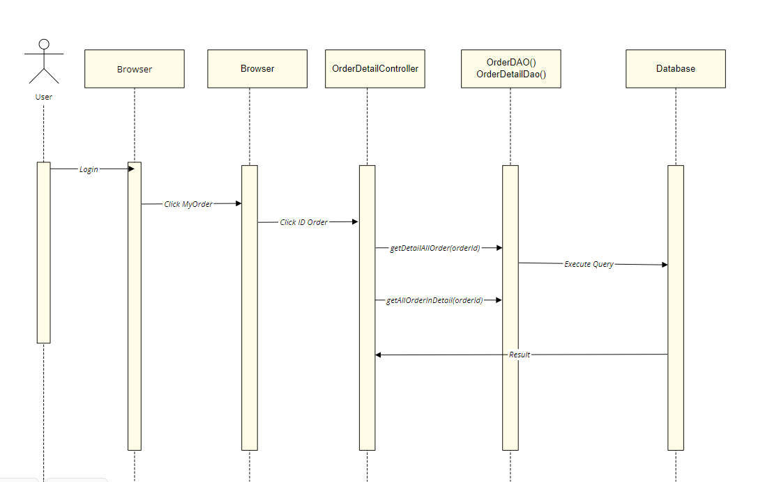

### d. Database queries

select * from [Order] join Status_Order\n"

+ " on [Order].status_order= Status_Order.status_order_id\n"

+ " where order_id = ?

select * from Order_Detail join Product \n"

+ " on Order_Detail.product_id = Product.product_id\n"

+ " join Products_Images on Order_Detail.product_id = Products_Images.product_id\n"

+ " join Category on Product.category_id = Category.category_id\n"

+ " where order_id = ?

## 18. Marketing/MKT Dashboard

### a. Class Diagram

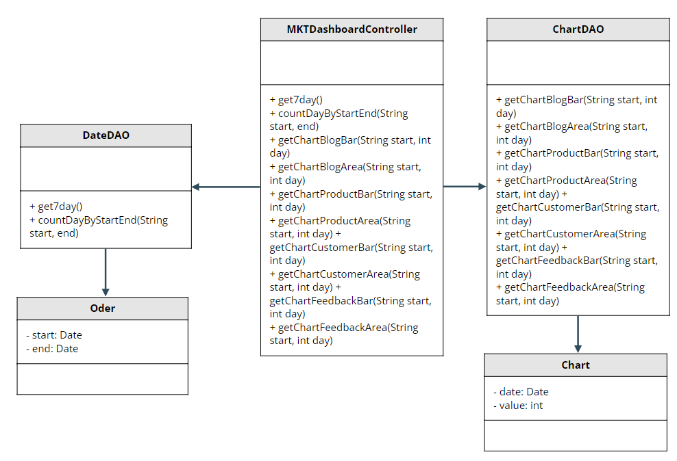

### b. Class Specifications

#### XYZ Class

| **No** | **Method** | **Description** |
| --- | --- | --- |
| *01* | *get7day()* | *Get last seven days* |
| *02* | *countDayByStartEnd()* | *Count the number of days difference between start and end* |
| *03* | *getChartBlogBar()* | *Get statistics by bar chart from start date to end date of post* |
| *04* | *getChartBlogArea()* | *Get statistics by area chart from start date to end date of post* |
| *05* | *getChartProductBar()* | *Get statistics by bar chart from start date to end date of product* |
| *06* | *getChartProductArea()* | *Get statistics by area chart from start date to end date of product* |
| *07* | *getChartCustomerBar()* | *Get statistics by bar chart from start date to end date of customer* |
| *08* | *getChartCustomerArea()* | *Get statistics by area chart from start date to end date of customer* |
| *09* | *getChartFeedbackBar()* | *Get statistics by bar chart from start date to end date of feedback* |
| *10* | *getChartFeedbackArea()* | *Get statistics by area chart from start date to end date of feedback* |

### c. Sequence Diagram(s)

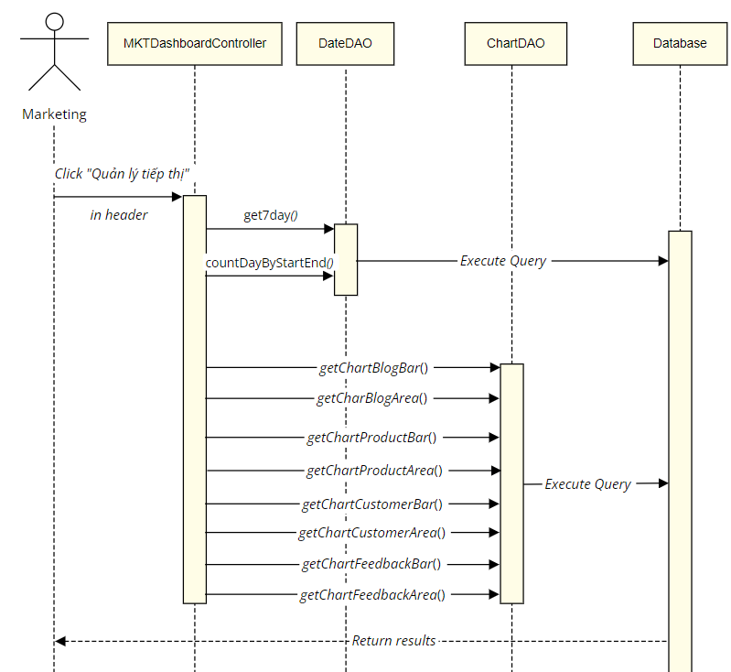

### d. Database queries

* select GETDATE(), GETDATE()-6
* SELECT DATEDIFF(day, ?, ?)
* select DATEADD(DAY, ?, ?)
* select count(*) from Blog where updated_date = DATEADD(DAY, ?, ?) and status = 1
* select count(*) from Blog where updated_date <= DATEADD(DAY, ?, ?) and status = 1
* select count(*) from Product where update_date = DATEADD(DAY, ?, ?) and status = 1
* select count(*) from Product where update_date <= DATEADD(DAY, ?, ?) and status = 1
* select count(*) from Customer where updated_date = DATEADD(DAY, ?, ?) and status = 1
* select count(*) from Customer where updated_date <= DATEADD(DAY, ?, ?) and status = 1
* select count(*) from Feedback where date = DATEADD(DAY, ?, ?) and status = 1
* select count(*) from Feedback where date <= DATEADD(DAY, ?, ?) and status = 1

## 19. Marketing/Posts List

### a. Class Diagram

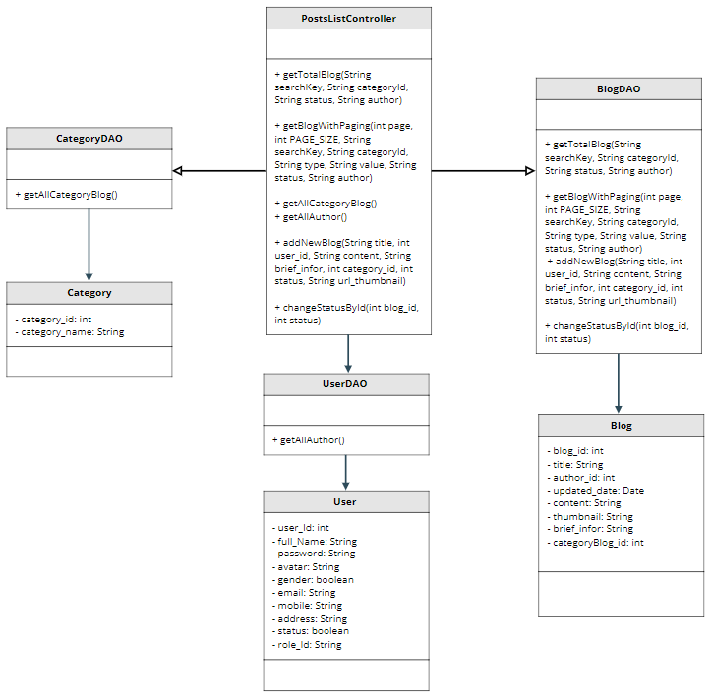

### b. Class Specifications

#### XYZ Class

| **No** | **Method** | **Description** |
| --- | --- | --- |
| *01* | *getTotalBlog()* | *Get count total blog* |
| *02* | *getBlogWithPaging()* | *Get all post list is paginated* |
| *03* | *getAllCategoryBlog()* | *Get all category of blog* |
| *04* | *getAllAuthor()* | *Get all author of blog* |
| *05* | *addNewBlog()* | *Add new blog* |
| *06* | *changeStatusById()* | *Change status of specific blog* |

### c. Sequence Diagram(s)

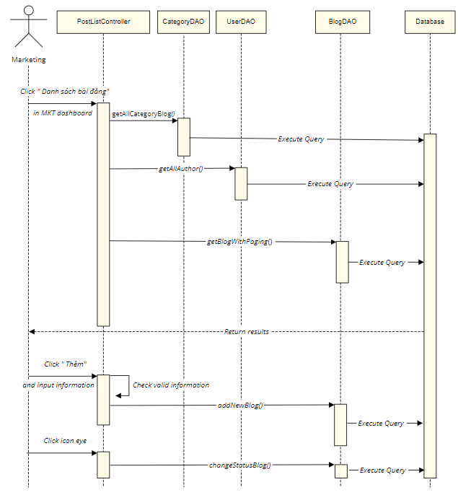

### d. Database queries

* Select count(*) from Blog where categoryBlog_id " + categoryId + " and [status] " + status + " and author_id " + author + " and title like N'%" + searchKey + "%'
* select * from Blog where categoryBlog_id " + categoryId + " and [status] " + status + " and author_id " + authorId + " and [title] like N'%" + searchKey + "%' order by " + value + " " + type + " offset (?-1)*? row fetch next ? row only
* Select * from Category_Blog
* select * from [User] where role_id = 2
* INSERT INTO [dbo].[Blog] ( [title], [author_id], [content], [thumbnail], [brief_infor], [categoryBlog_id], [status]) VALUES (?,?,?,?,?,?,?)
* UPDATE [dbo].[Blog] SET [status] = ? WHERE blog_id = ?

## 20. Marketing/Post Details

### a. Class Diagram

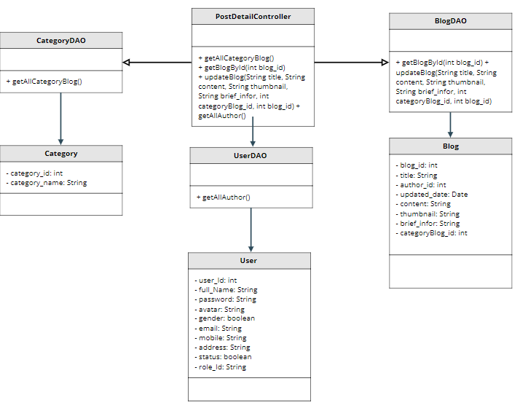

### b. Class Specifications

#### XYZ Class

| **No** | **Method** | **Description** |
| --- | --- | --- |
| *01* | *getAllCategoryBlog()* | *Get all category of blog* |
| *02* | *getBlogById()* | *Get all information of specific blog* |
| *03* | *updateBlog()* | *Update information of specific blog* |
| *04* | *getAllAuthor* | *Get all author of blog* |

### c. Sequence Diagram(s)

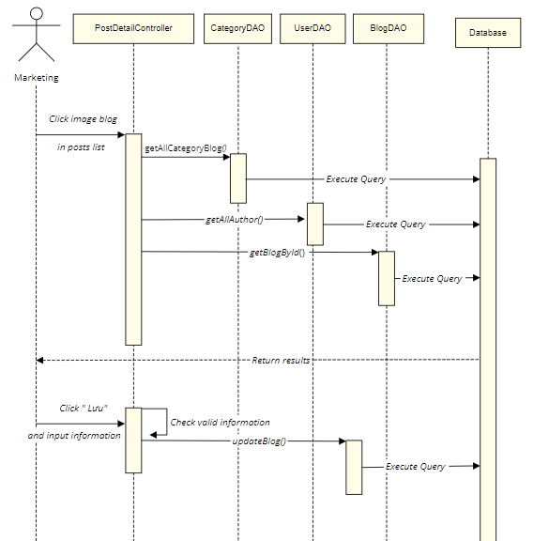

### d. Database queries

* Select * from Blog where blog_id = ?
* Select * from Category_Blog
* select * from [User] where role_id = 2
* UPDATE [dbo].[Blog] SET [title] = ? ,[author_id] = ? ,[updated_date] = getdate() ,[content] = ? ,[thumbnail] = ? ,[brief_infor] = ? ,[categoryBlog_id] = ? ,[status] = ? WHERE blog_id = ?

## 21. Marketing/Sliders List

### a. Class Diagram

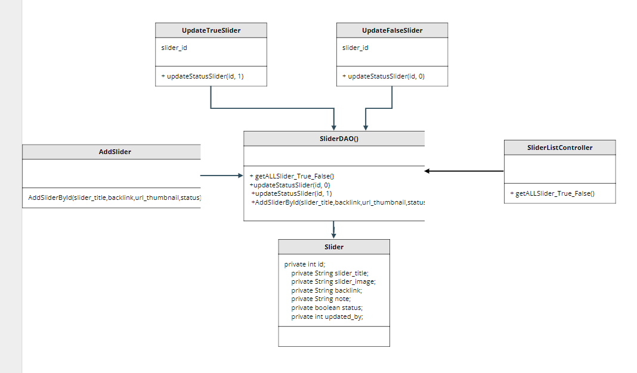

### b. Class Specifications

#### XYZ Class

| **No** | **Method** | **Description** |
| --- | --- | --- |
| *01* | *getALLSlider_True_False()* | *get all sliders (including status true and false)* |
| *02* | *updateStatusSlider(id, 0)* | *update slider status from true to false* |
| *03* | *updateStatusSlider(id, 1)* | *update slider status from false to true* |
| *04* | *AddSliderById(slider_title,backlink,url_thumbnail,status)* | *Add 1 new slider (include title, backlink, thumbnail and status)* |

### c. Sequence Diagram(s)

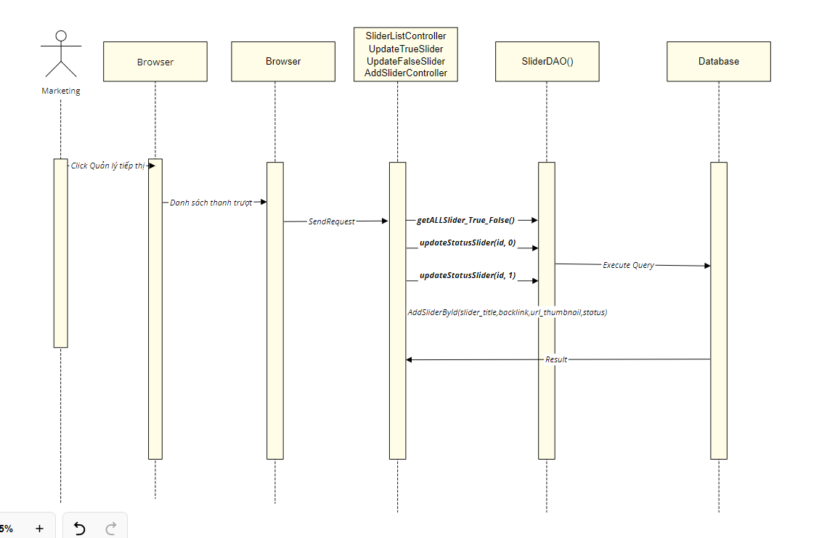

### d. Database queries

INSERT INTO [dbo].[Slider]\n"

+ " (slider_title\n"

+ " ,slider_image\n"

+ " ,backlink\n"

+ " ,[status])\n"

+ " VALUES\n"

+ " (?,?,?,?)

UPDATE [dbo].[Slider]\n"

+ " SET status = ?\n"

+ " WHERE slider_id = ?

SELECT * FROM [dbo].[Slider]

## 22. Marketing/Slider Details

### a. Class Diagram

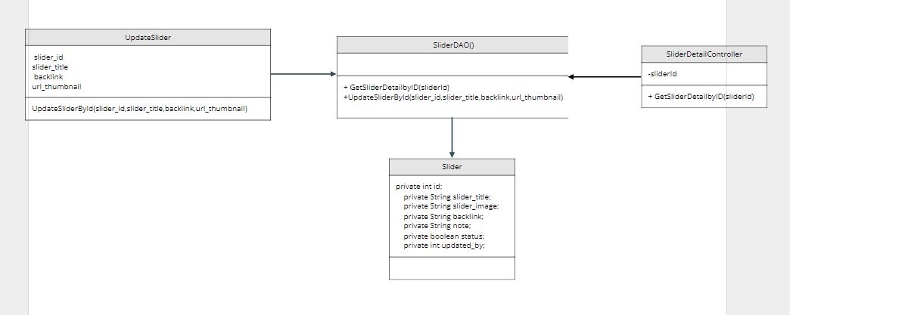

### b. Class Specifications

#### XYZ Class

| **No** | **Method** | **Description** |
| --- | --- | --- |
| *01* | *GetSliderDetailbyID(sliderId)* | *Get slider's information by sliderId* |
| *02* | *UpdateSliderById(slider_id,slider_title,backlink,url_thumbnail)* | *update information of slider* |

### c. Sequence Diagram(s)

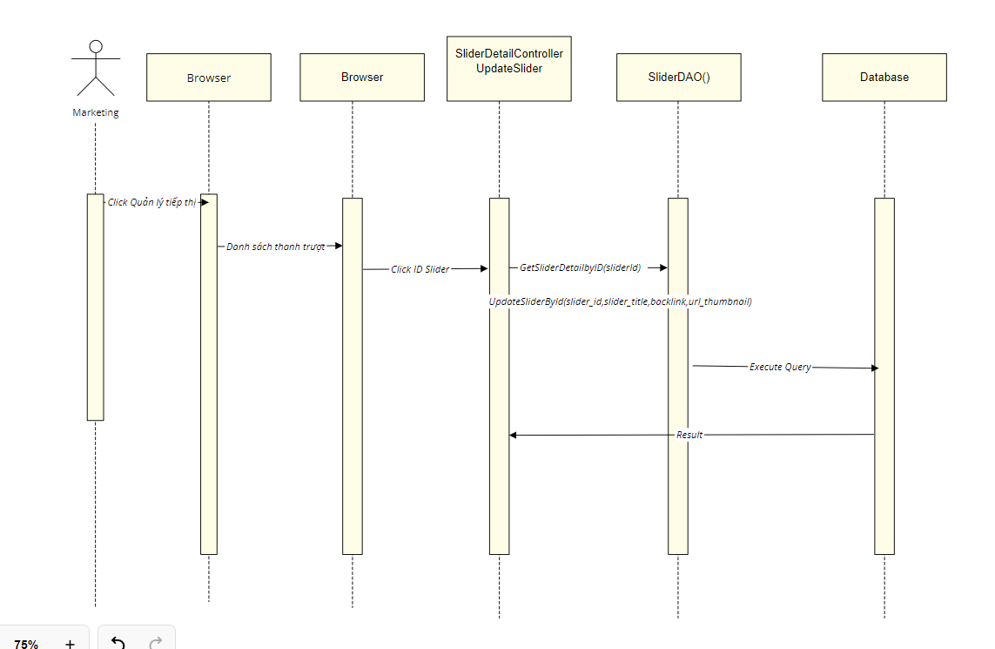

### d. Database queries

UPDATE [dbo].[Slider]\n"

+ " SET [slider_title] = ?\n"

+ " ,[slider_image] = ?\n"

+ " ,[backlink] = ?\n"

+ " WHERE slider_id = ?

SELECT * FROM [dbo].[Slider] where slider_id = ?

## 23. Marketing/Products List

### a. Class Diagram

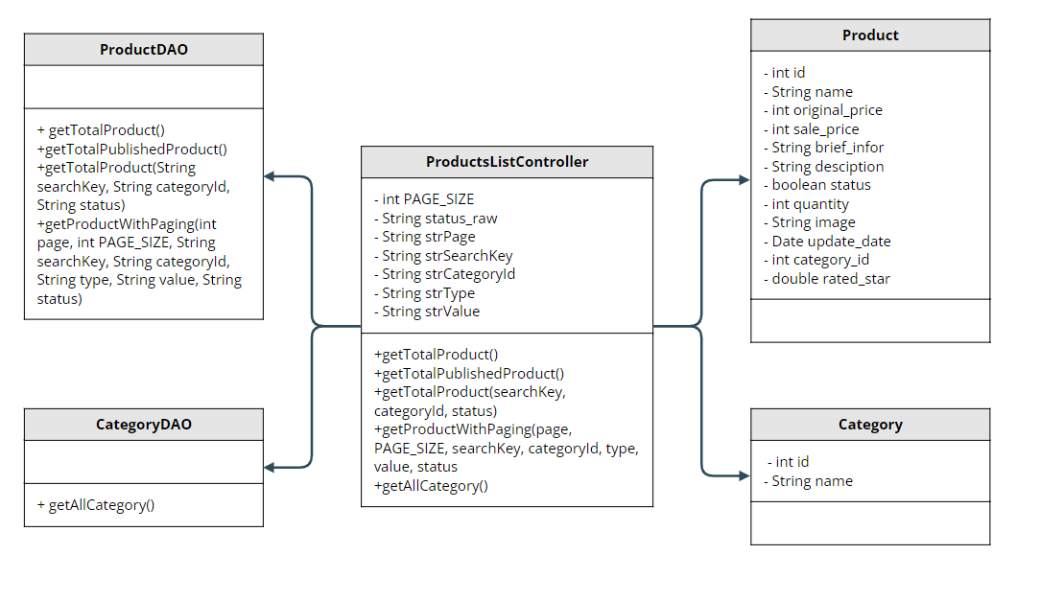

### b. Class Specifications

#### 

| **No** | **Method** | **Description** |
| --- | --- | --- |
| *01* | *getTotalProduct()* | *Get number of all product* |
| *02* | *getTotalPublishedProduct()* | *Get number of all publushedProduct* |
| *03* | *getTotalProduct(String searchKey, String categoryId, String status)* | *Get number of all product by searchKey,categoryId,status* |
| *04* | *getProductWithPaging(int page, int PAGE_SIZE, String searchKey, String categoryId, String type, String value, String status)* | *Get list product by type of search and paging* |
| *05* | *getAllCategory()* | *Get all category for search by category* |

### c. Sequence Diagram(s)

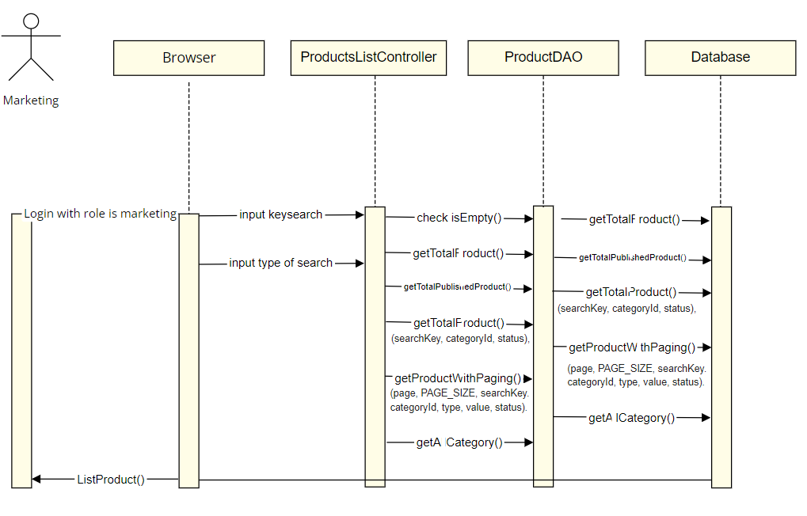

### d. Database queries

-Select * from Category

-select COUNT(product_id) from Product

-select COUNT(product_id) from Product where status = 1

-Select count(product_id) from Product "

+ "where category_id " + categoryId + " and status "+status+" and product_name like N'%" + searchKey + "%'\n

-select * from Product\n"

+ "where category_id " + categoryId + " and status " + status + " and product_name like N'%" + searchKey + "%'\n"

+ " order by " + value + " " + type + " offset (?-1)*? row fetch next ? row only

## 24. Marketing/Product Details

### a. Class Diagram

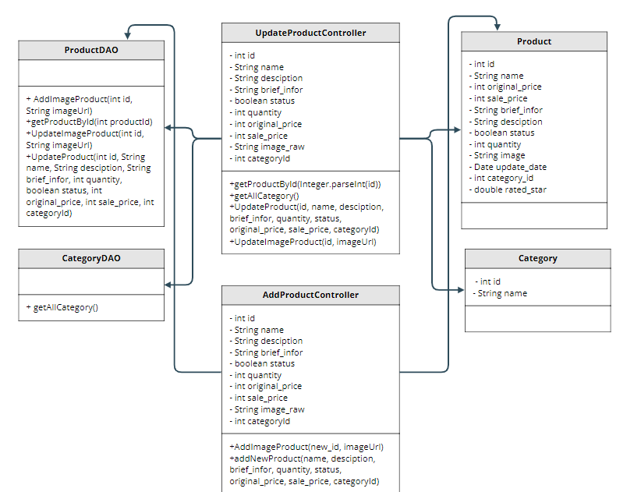

### b. Class Specifications

#### XYZ Class

| **No** | **Method** | **Description** |
| --- | --- | --- |
| *01* | *getProductById(int productId)* | *Get product by id* |
| *02* | *UpdateProduct(int id, String name, String desciption, String brief_infor, int quantity, boolean status, int original_price, int sale_price, int categoryId)* | *Update product with all (- image) by id* |
| *03* | *UpdateImageProduct(int id, String imageUrl)* | *Update image product by id* |
| *04* | *addNewProduct(String name, String desciption, String brief_infor, int quantity, boolean status, int original_price, int sale_price, int categoryId)* | *Add new product will all (- image)* |
| *05* | *AddImageProduct(int id, String imageUrl)* | *Add image product by id* |
| *06* | *getAllCategory()* | *Get all category* |

### c. Sequence Diagram(s)

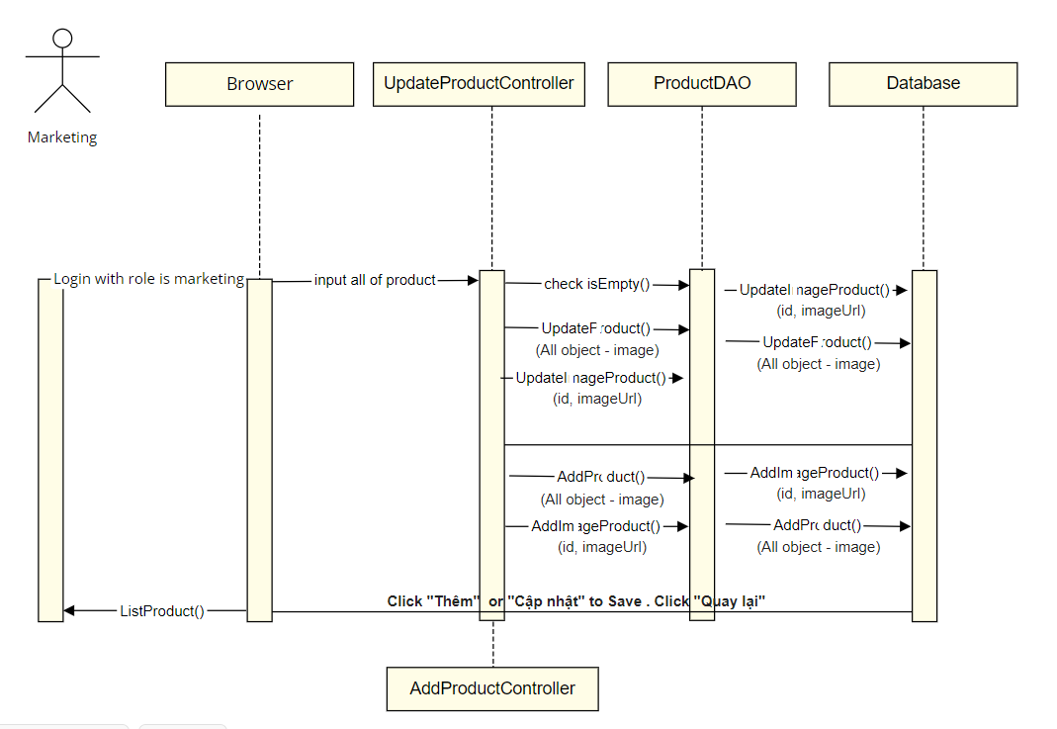

### d. Database queries

-INSERT INTO [dbo].[Product]\n"

+ " ([product_name]\n"

+ " ,[original_prices]\n"

+ " ,[sale_prices]\n"

+ " ,[product_details]\n"

+ " ,[brief_infor]\n"

+ " ,[status]\n"

+ " ,[quantity]\n"

+ " ,[category_id])\n"

+ " VALUES\n"

+ " (?,?,?,?,?,?,?,?)

-INSERT INTO [dbo].[Products_Images]\n"

+ " ([product_id]\n"

+ " ,[images])\n"

+ " VALUES\n"

+ " (?,?)

-select * from Product where product_id = ?

-Select * from Category

-UPDATE [dbo].[Product]\n"

+ " SET [product_name] = ?\n"

+ " ,[original_prices] = ?\n"

+ " ,[sale_prices] = ?\n"

+ " ,[product_details] = ?\n"

+ " ,[brief_infor] = ?\n"

+ " ,[status] = ?\n"

+ " ,[quantity] = ?\n"

+ " ,[category_id] = ?\n"

+ "\n"

+ " WHERE product_id = ?

-UPDATE [dbo].[Products_Images]\n"

+ " SET\n"

+ " [images] = ?\n"

+ " WHERE product_id = ?

## 25. Marketing/Customers List

### a. Class Diagram

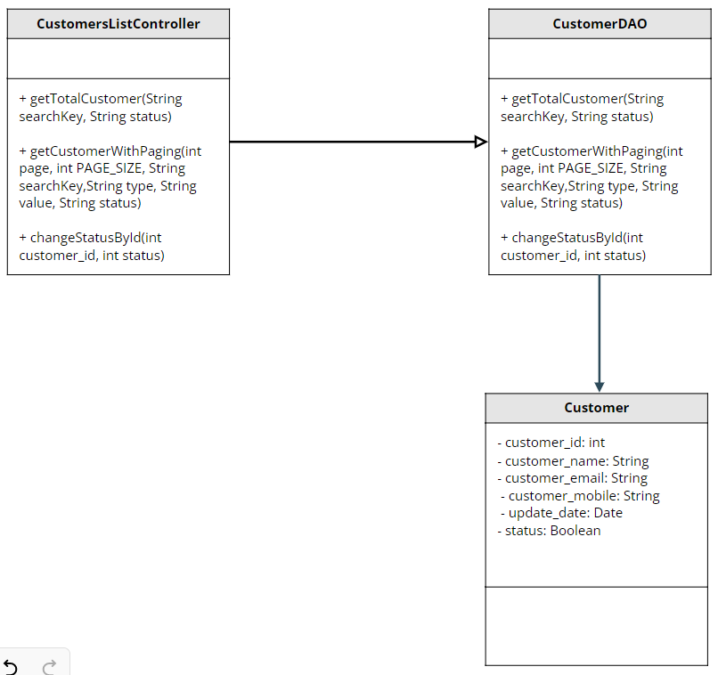

### b. Class Specifications

| **No** | **Method** | **Description** |
| --- | --- | --- |
| *01* | *getTotalCustomer()* | *Get total customer in the database* |
| *02* | *getCustomerWithPaing()* | *Get list all customer in the database pagined* |
| *03* | *changeStatusById()* | *Change status of specific customer* |

### c. Sequence Diagram(s)

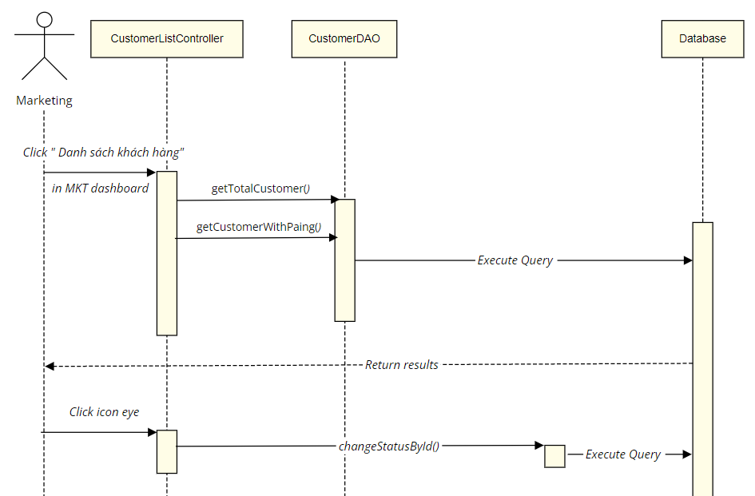

### d. Database queries

* Select count(*) from Customer where [status] " + status + " and customer_name like N'%" + searchKey + "%'
* select * from Customer where [status] " + status + " and [customer_name] like N'%" + searchKey + "%' order by " + value + " " + type + " offset (?-1)*? row fetch next ? row only
* UPDATE [dbo].[Customer] SET [status] = ? WHERE customer_id = ?

## 26. Marketing/Customer Details

### a. Class Diagram

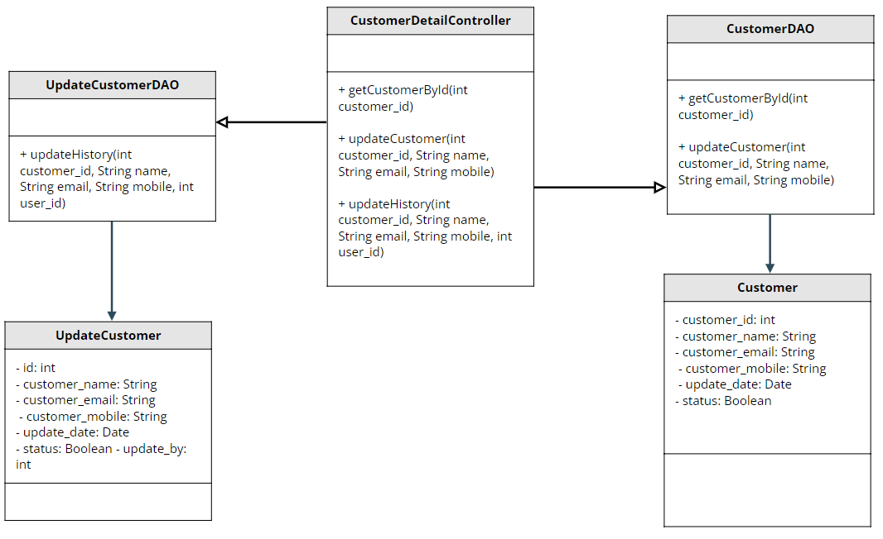

### b. Class Specifications

| **No** | **Method** | **Description** |
| --- | --- | --- |
| *01* | *getCustomerById()* | *Get customer by id* |
| *02* | *updateCustomer()* | *Update customer in the database* |
| *03* | *UpdateHistory()* | *Update history for each time update customer* |

### c. Sequence Diagram(s)

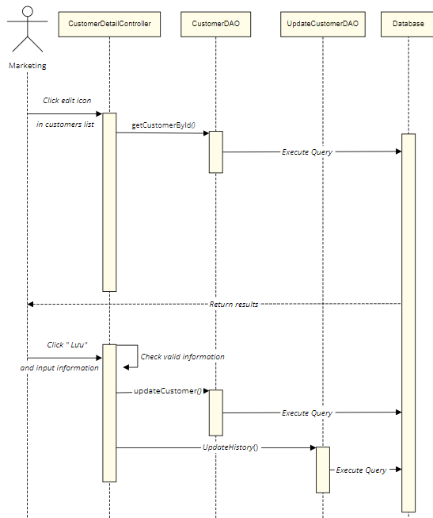

### d. Database queries

* select * from [Customer] where customer_id = ?
* update dbo.[Customer] set [customer_name] = ?, customer_email = ?, customer_mobile = ?, updated_date = getdate() where customer_id = ?
* INSERT INTO [dbo].[Update_Customer] ([customer_id] ,[email],[fullName] ,[mobile] ,[update_by]) VALUES (?,?,?,?,?)

## 27. Marketing/Feedbacks List

### a. Class Diagram

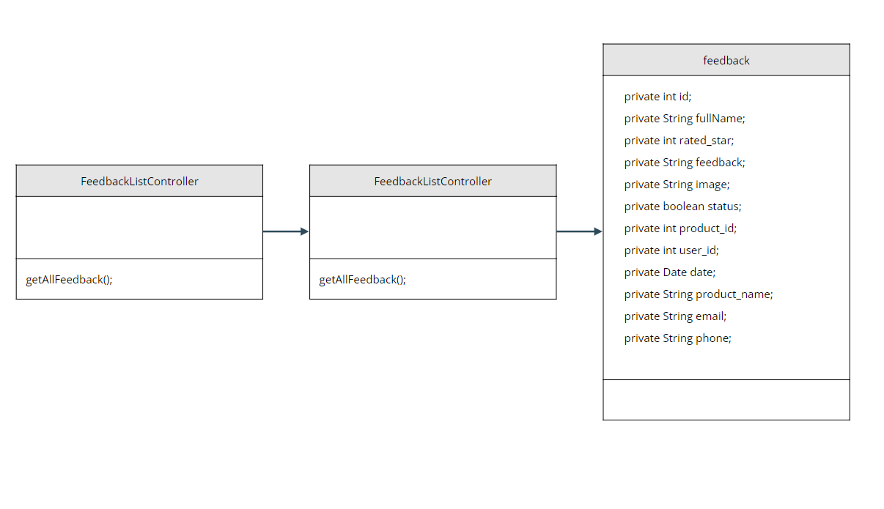

### b. Class Specifications

#### XYZ Class

| **No** | **Method** | **Description** |
| --- | --- | --- |
| *01* | *getAllFeedback();* | *get all feedback in table feedback database* |

### c. Sequence Diagram(s)

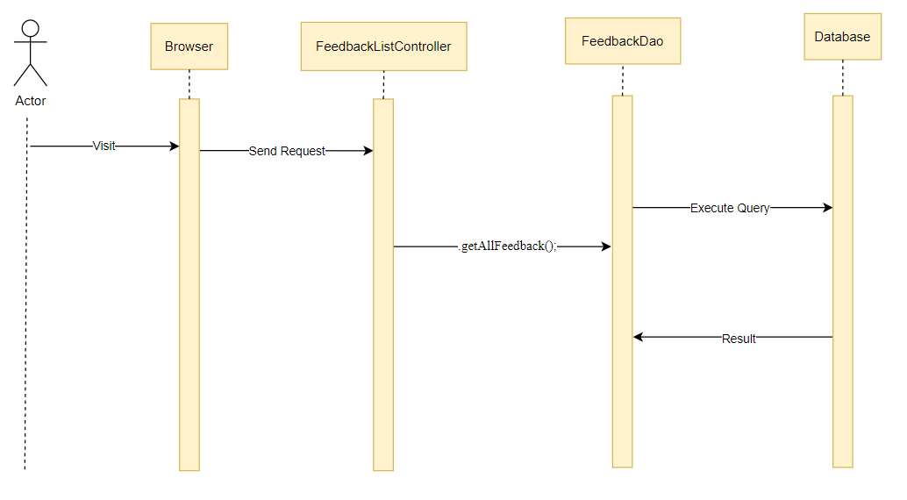

### d. Database queries

select f.*, p.product_name \n"

+ "from Feedback f join Product p \n"

+ "on f.product_id = p.product_id";

## 28. Marketing/Feedback Details

### a. Class Diagram

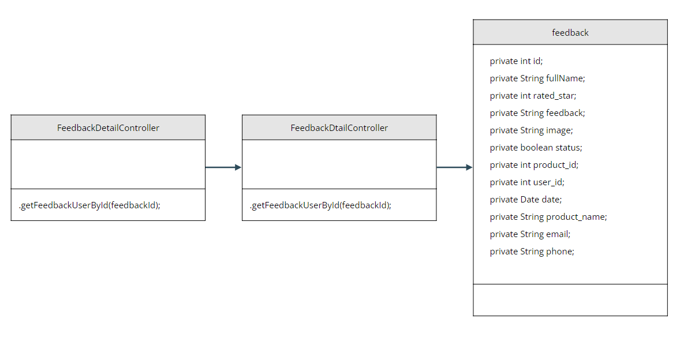

### b. Class Specifications

#### XYZ Class

| **No** | **Method** | **Description** |
| --- | --- | --- |
| *01* | *.getFeedbackUserById(feedbackId);* | *get feedback user by id_feedback in table Feedback* |

### c. Sequence Diagram(s)

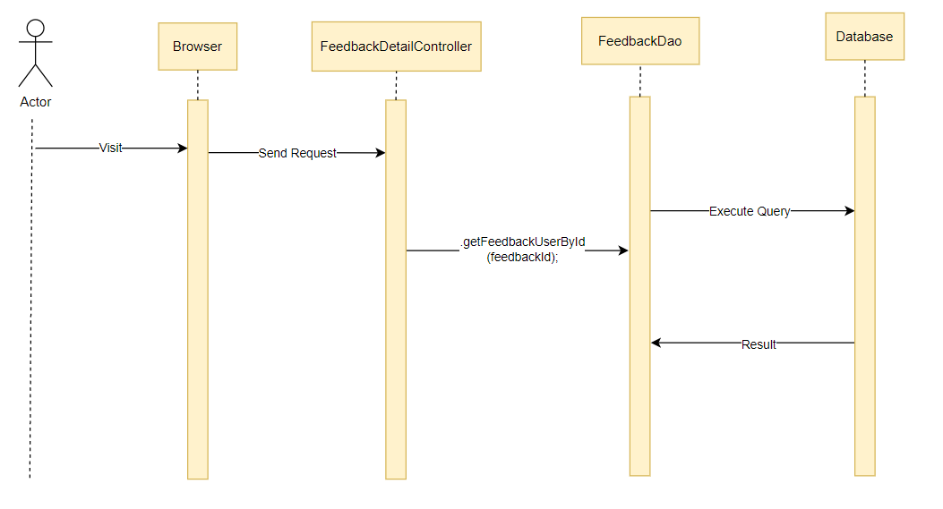

### d. Database queries

select f.*, p.product_name, u.email , u.mobile\n"

+ "from Feedback f \n"

+ "join Product p on f.product_id = p.product_id\n"

+ "join [User] u on f.userId = u.userId\n"

+ "where f.feedBack_id = ?"

## 29. Sale/Sale Dashboard

### a. Class Diagram

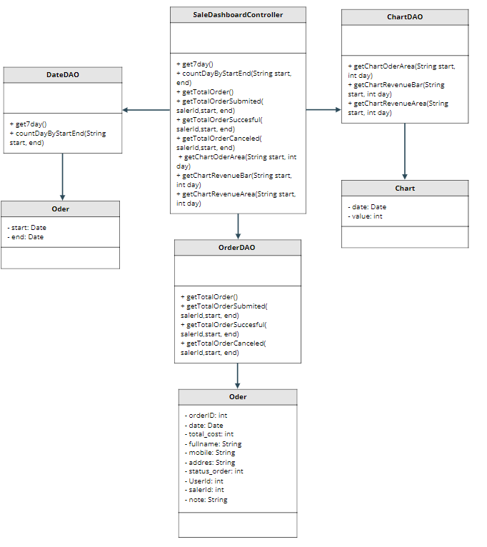

### b. Class Specifications

#### XYZ Class

| **No** | **Method** | **Description** |
| --- | --- | --- |
| *01* | *get7day()* | *Get last seven days* |
| *02* | *countDayByStartEnd()* | *Count the number of days difference between start and end* |
| *03* | *getTotalOrder()* | *Get total order* |
| *04* | *getTotalOrderSubmitted()* | *Get total order have status is submitted* |
| *05* | *getTotalOrderSuccessful()* | *Get total order have status is successful* |
| *06* | *getTotalOrderCanceled()* | *Get total order have status is canceled* |
| *07* | *getChartOrderBar()* | *Get statistics by bar chart from start date to end date of order* |
| *08* | *getChartOrderrArea()* | *Get statistics by area chart from start date to end date of order* |
| *09* | *getChartRevenueBar()* | *Get statistics by bar chart from start date to end date of revenue* |
| *10* | *getChartRevenuekArea()* | *Get statistics by area chart from start date to end date of revenue* |

### c. Sequence Diagram(s)

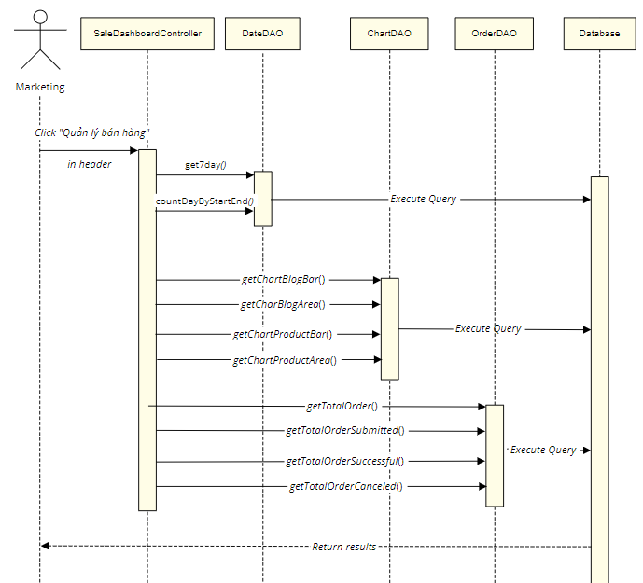

### d. Database queries

* select GETDATE(), GETDATE()-6
* SELECT DATEDIFF(day, ?, ?)
* select DATEADD(DAY, ?, ?)
* select count(*) from [Order] where saler_id " + salerId + " and orderDate <= ? and orderDate >= ?
* select count(*) from [Order] where saler_id " + salerId + " and orderDate <= ? and orderDate >= ? and status_order = 1
* select count(*) from [Order] where saler_id " + salerId + " and orderDate <= ? and orderDate >= ? and status_order = 2
* select count(*) from [Order] where saler_id " + salerId + " and orderDate <= ? and orderDate >= ? and status_order = 3
* select count(*) from [Order] where saler_id " + salerId + " and orderDate = DATEADD(DAY, ?, ?)
* select sum(total_cost) from [Order] where saler_id " + salerId + " and orderDate = DATEADD(DAY, ?, ?)
* select sum(total_cost) from [Order] where saler_id " + salerId + " and orderDate <= DATEADD(DAY, ?, ?) and orderDate >= ?

## 30. Sale/Orders List

### a. Class Diagram

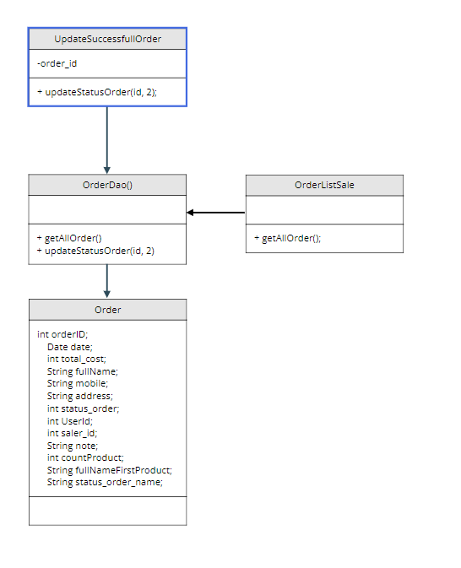

### b. Class Specifications

#### XYZ Class

| **No** | **Method** | **Description** |
| --- | --- | --- |
| *01* | *getAllOrder()* | *Display information of orders (including product, total cost, sale_id, user_id)* |
| *02* | *updateStatusOrder(id, 2)* | *Update the successful status of the order* |

### c. Sequence Diagram(s)

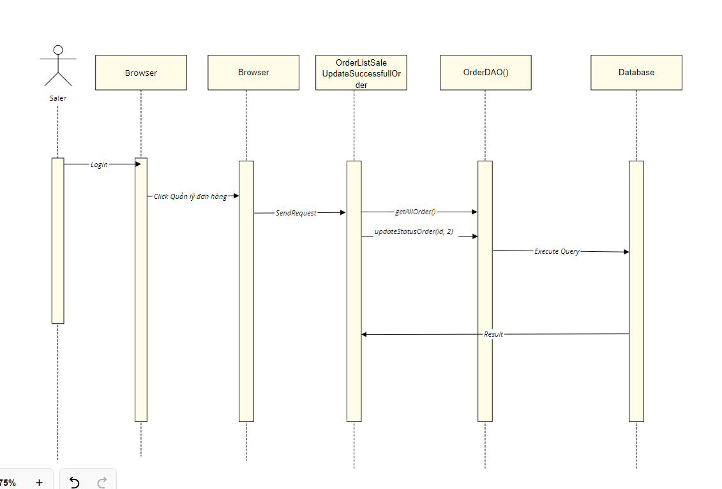

### d. Database queries

UPDATE [dbo].[Order]\n"

+ " SET [status_order] = ?\n"

+ " WHERE order_id = ?

select * from [Order] join Status_Order\n"

+ " on [Order].status_order= Status_Order.status_order_id

## 31. Sale/Order Details

### a. Class Diagram

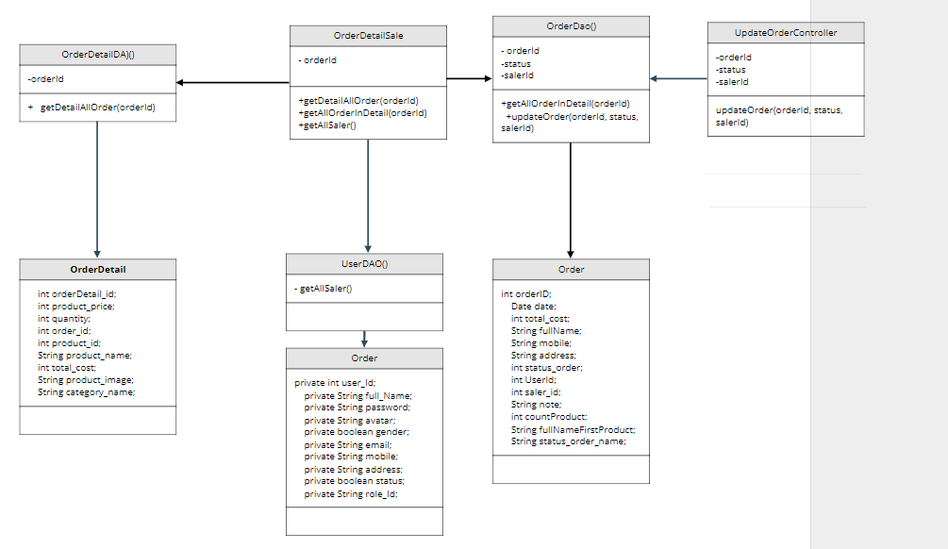

### b. Class Specifications

#### XYZ Class

| **No** | **Method** | **Description** |
| --- | --- | --- |
| *01* | *getDetailAllOrder(orderId)* | *Get information about purchased products* |
| *02* | *getAllOrderInDetail(orderId)* | *get customer information of the order* |
| *03* | *getAllSaler()* | *Get the IDs of all the salers* |
| *04* | *updateOrder(orderId, status, salerId)* | *Update order again (based on orderId, status, salerId)* |

### c. Sequence Diagram(s)

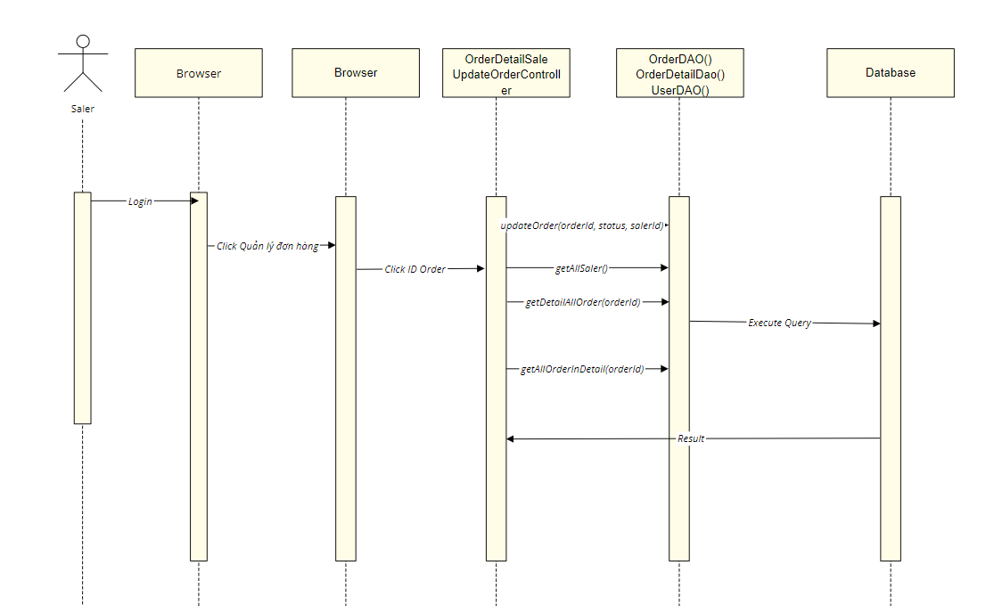

### d. Database queries

UPDATE [dbo].[Order]\n"

+ " SET [status_order] = ? \n"

+ " ,[saler_id] = ? \n"

+ " WHERE order_id = ?

select * from Order_Detail join Product \n"

+ " on Order_Detail.product_id = Product.product_id\n"

+ " join Products_Images on Order_Detail.product_id = Products_Images.product_id\n"

+ " join Category on Product.category_id = Category.category_id\n"

+ " where order_id = ?

select * from [Order] join Status_Order\n"

+ " on [Order].status_order= Status_Order.status_order_id\n"

+ " where order_id = ?

select * from [User] where role_id = 3

## 32. Admin/Admin Dashboard

### a. Class Diagram

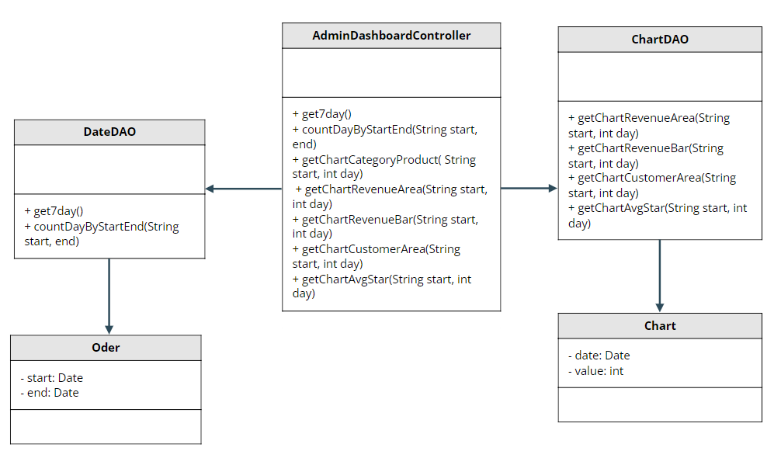

### b. Class Specifications

#### XYZ Class

| **No** | **Method** | **Description** |
| --- | --- | --- |
| *01* | *get7day()* | *Get last seven days* |
| *02* | *countDayByStartEnd()* | *Count the number of days difference between start and end* |
| *03* | *getChartCategoryProduct()* | *Get chart for each category of product* |
| *04* | *getChartRevenueBar()* | *Get statistics by bar chart from start date to end date of revenue* |
| *05* | *getChartRevenueArea()* | *Get statistics by area chart from start date to end date of revenue* |
| *06* | *getChartCustomerArea()* | *Get statistics by area chart from start date to end date of customer* |
| *07* | *getChartAvgStar()* | *Get statistics chart for average rating stars* |

### c. Sequence Diagram(s)

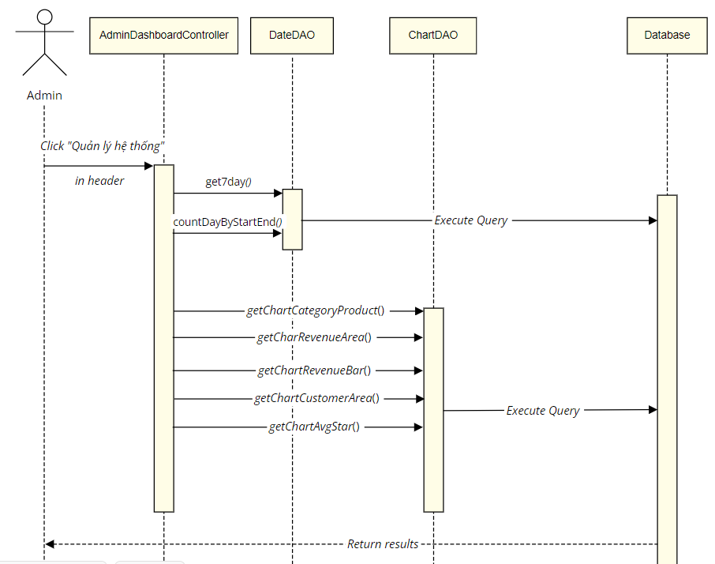

### d. Database queries

* select GETDATE(), GETDATE()-6
* SELECT DATEDIFF(day, ?, ?)
* select DATEADD(DAY, ?, ?)
* select COUNT(*) from Product where update_date < ?
* select COUNT(*) from Product where category_id = ? and update_date < ?
* select sum(total_cost) from [Order] where saler_id " + salerId + " and orderDate <= DATEADD(DAY, ?, ?) and orderDate >= ?
* select count(*) from Customer where updated_date <= DATEADD(DAY, ?, ?)
* select CAST(AVG(rated_star) AS DECIMAL(10,1)) from Feedback where date < DATEADD(DAY, ?, ?)

## 33. Admin/Users List

### a. Class Diagram

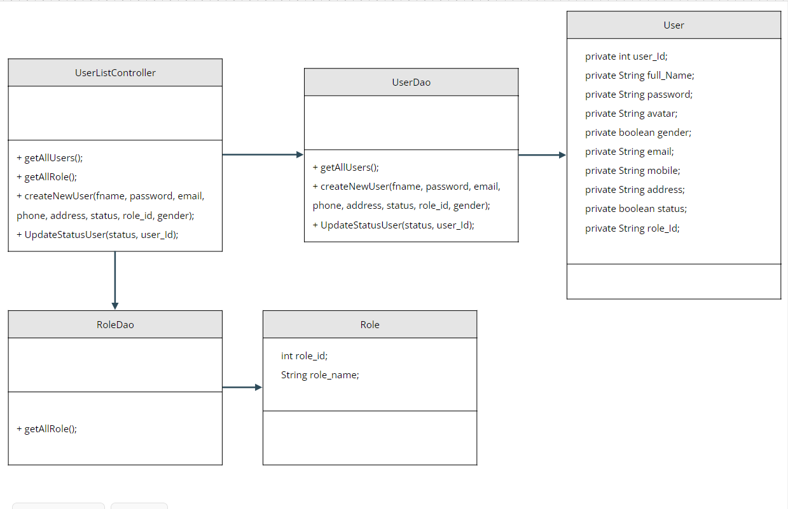

### b. Class Specifications

#### XYZ Class

| **No** | **Method** | **Description** |
| --- | --- | --- |
| *01* | *getAllUsers();* | *get all user in database* |
| *02* | *getAllRole();* | *get all role in database* |
| *03* | *createNewUser(fname, password, email, phone, address, status, role_id, gender);* | *create new User to table User in database* |
| *04* | *UpdateStatusUser(status, user_Id);* | *update status to table User in database* |

### c. Sequence Diagram(s)

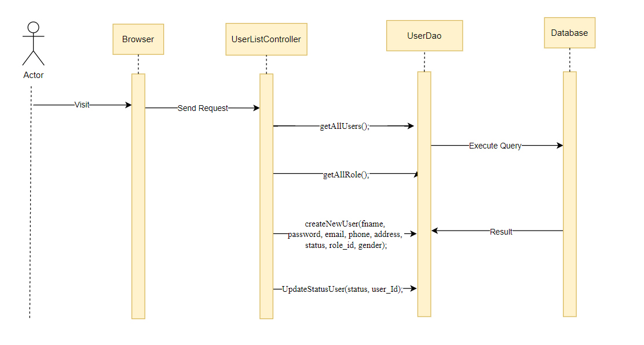

### d. Database queries

select * from [User]

select * from Role

UPDATE [dbo].[User]\n"

+ " SET [status] = ?\n"

+ " WHERE userId = ?"

INSERT INTO [dbo].[User]\n"

+ " ([fullName]\n"

+ " ,[password]\n"

+ " ,[email]\n"

+ " ,[mobile]\n"

+ " ,[address]\n"

+ " ,[status]\n"

+ " ,[role_id]\n"

+ " ,[gender])\n"

+ " VALUES\n"

+ " (?,?,?,?,?,?,?,?)"

## 34. Admin/User Details

### a. Class Diagram

### b. Class Specifications

#### XYZ Class

| **No** | **Method** | **Description** |
| --- | --- | --- |
| *01* |  |  |
| *02* |  |  |
| *03* |  |  |
| *04* |  |  |

### c. Sequence Diagram(s)

### d. Database queries

## 35. Admin/Settings List

### a. Class Diagram

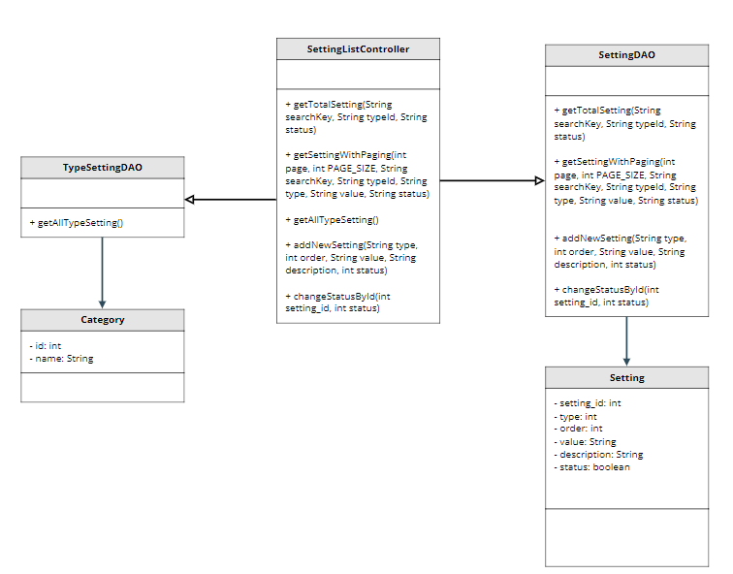

### b. Class Specifications

| **No** | **Method** | **Description** |
| --- | --- | --- |
| *01* | *getTotalSetting()* | *Get total setting in the database* |
| *02* | *getSettingWithPaging()* | *Get list setting pagination* |
| *03* | *getAllTypeSetting()* | *Get list type setting in the database* |
| *04* | *addNewSetting()* | *Add new setting* |
| *05* | *changeStatusById()* | *Change status of specific setting* |

### c. Sequence Diagram(s)

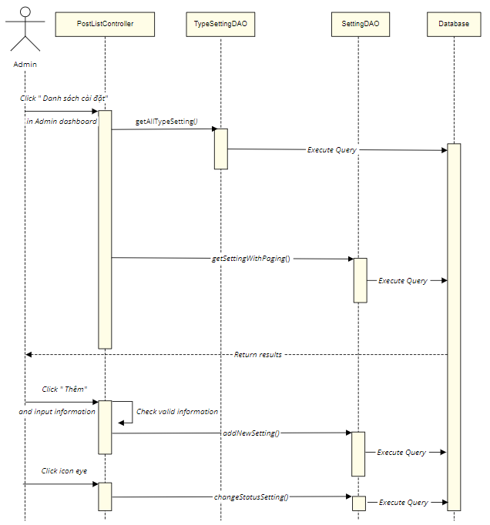

### d. Database queries

* Select count(*) from Setting where [type] " + typeId + " and [status] " + status + " and [value] like N'%" +searchKey + "%'
* select * from Setting where [type] " + typeId + " and [status] " + status + " and [value] like N'%" +searchKey + "%' order by " + value + " " + type + " offset (?-1)*? row fetch next ? row only
* INSERT INTO [dbo].[Setting] ([type] ,[order],[value],[description],[status]) VALUES (?,?,?,?,?)
* select * from Setting_Type

## 36. Admin/Setting Details

### a. Class Diagram

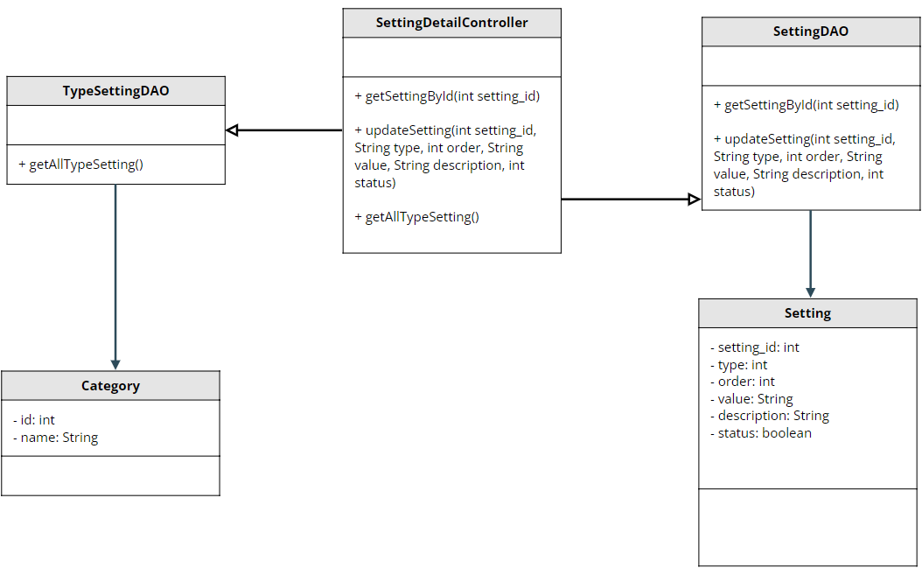

### b. Class Specifications

#### XYZ Class

| **No** | **Method** | **Description** |
| --- | --- | --- |
| *01* | *getSettingById(int setting_id)* | *Get specific setting by id* |
| *02* | *updateSetting()* | *Update setting by id* |
| *03* | *getAllTypeSetting()* | *Get list type setting in the database* |

### c. Sequence Diagram(s)

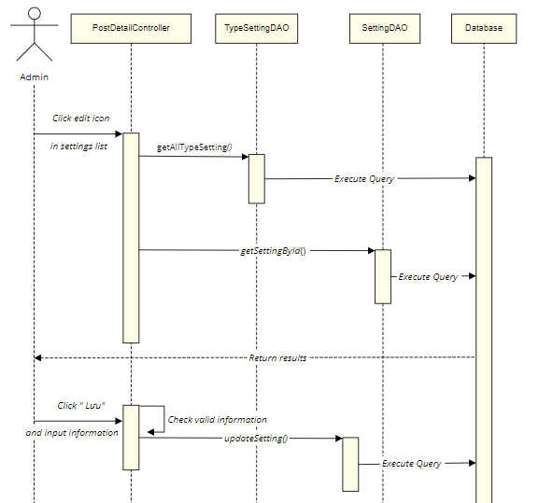

### d. Database queries

* select * from Setting s join Setting_Type st on s.type = st.setting_type_id where setting_id = ?
* UPDATE [dbo].[Setting] SET [value] = ?, [description] = ?, [status] = ? WHERE setting_id = ?
* UPDATE [dbo].[Category] SET [category_name] = ?,[status] = ? WHERE category_id = ?
* UPDATE [dbo].[Category_Blog] SET [categoryBlog_name] = ? ,[status] = ? WHERE categoryBlog_id = ?
* UPDATE [dbo].[Status_Order] SET [status_name] = ? ,[status] = ? WHERE status_order_id = ?
* UPDATE [dbo].[Role] SET [role_name] = ?,[status] = ? WHERE role_id = ?

## 37. Public/Blog List

### a. Class Diagram

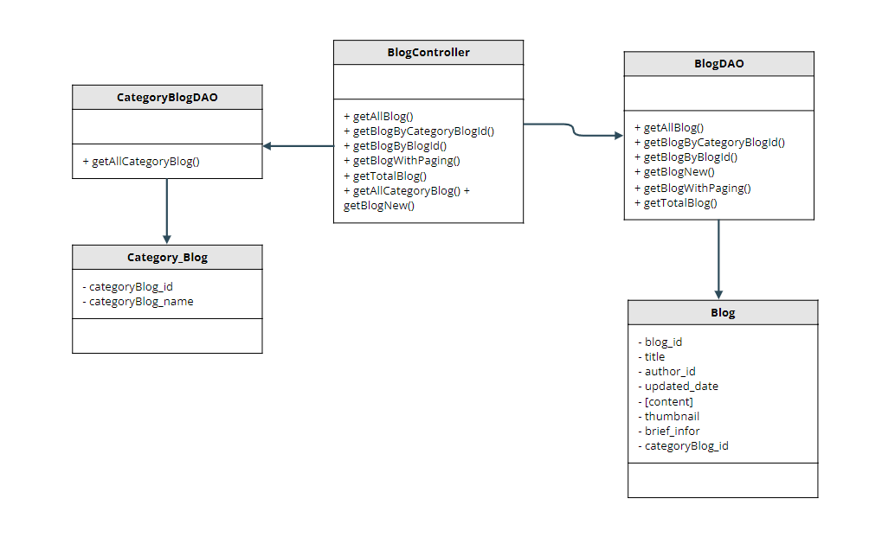

### b. Class Specifications

#### XYZ Class

| **No** | **Method** | **Description** |
| --- | --- | --- |
| *01* | *getAllBlog* | *get all blog in database* |
| *02* | *getBlogByCategoryBlogId* | *get blog by the category blog id* |
| *03* | *getBlogByBlogId* | *get blog by blog id* |
| *04* | *getBlogWithPaging* | *get blog with paging* |
| *05* | *getTotalBlog* | *get all blog by count* |
| *06* | *getAllCategoryBlog* | *get all category blog* |
| *07* | *getBlogNew* | *get new blog order by date* |

### c. Sequence Diagram(s)

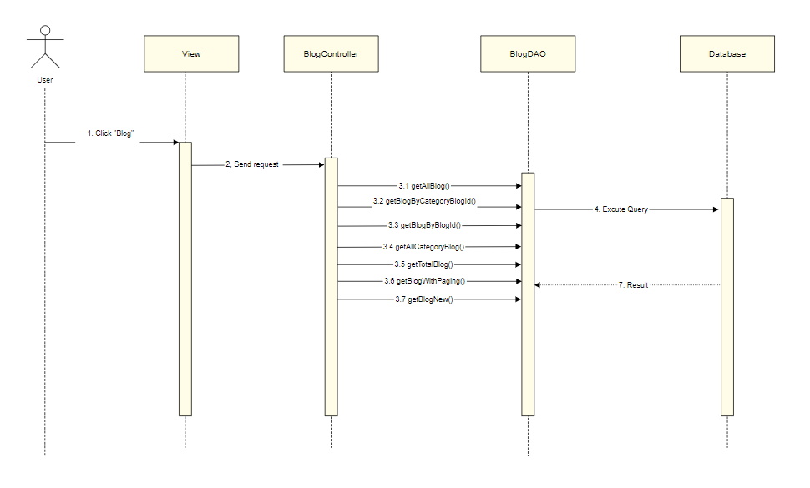

### d. Database queries

Select * from Blog

Select * from Blog where categoryBlog_id = ?

Select * from Blog where blog_id = ?

Select * from Category_Blog

select top 1 * from Blog order by updated_date desc

Select count(*) from Blog where categoryBlog_id + categoryId + " and title like N'% + searchKey + %'

select * from Blog

+ "where categoryBlog_id " + categoryId + " and title like N'%" + searchKey + "%'\n"

+ " order by " + value + " " + type + " offset (?-1)*? row fetch next ? row only

Select count(*) from Blog "

+ "where categoryBlog_id " + categoryId + " and [status] " + status + " and author_id " + author + " and title like N'%" + searchKey + "%'\n

## 38. Public/ Blog Details

### a. Class Diagram

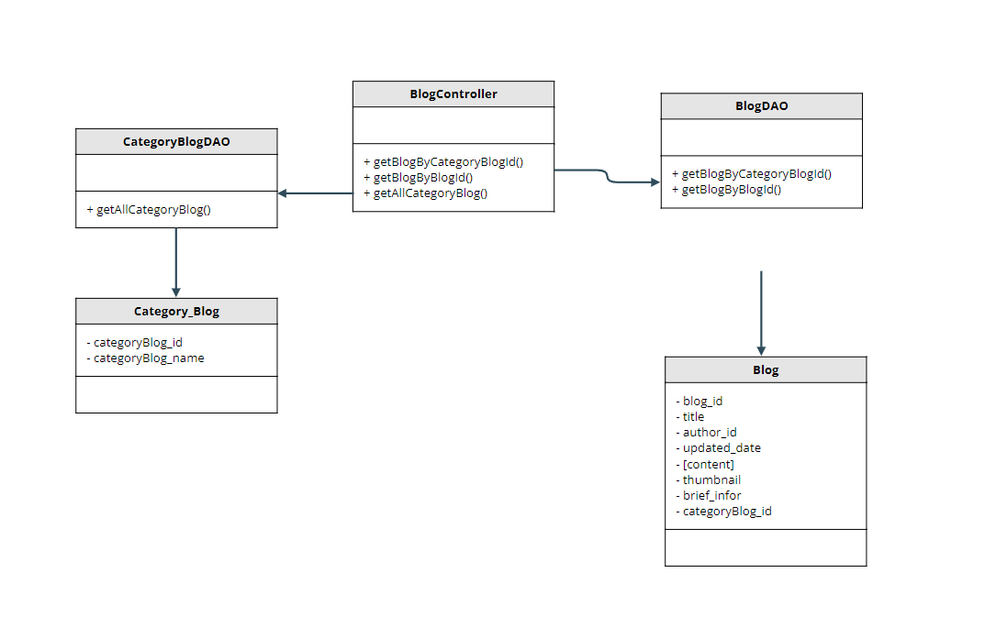

### b. Class Specifications

#### XYZ Class

| **No** | **Method** | **Description** |
| --- | --- | --- |
| *01* | *getAllBlog* | *get all blog in database* |
| *02* | *getBlogByCategoryBlogId* | *get blog by the category blog id* |
| *03* | *getBlogByBlogId* | *get blog by blog id* |

### c. Sequence Diagram(s)

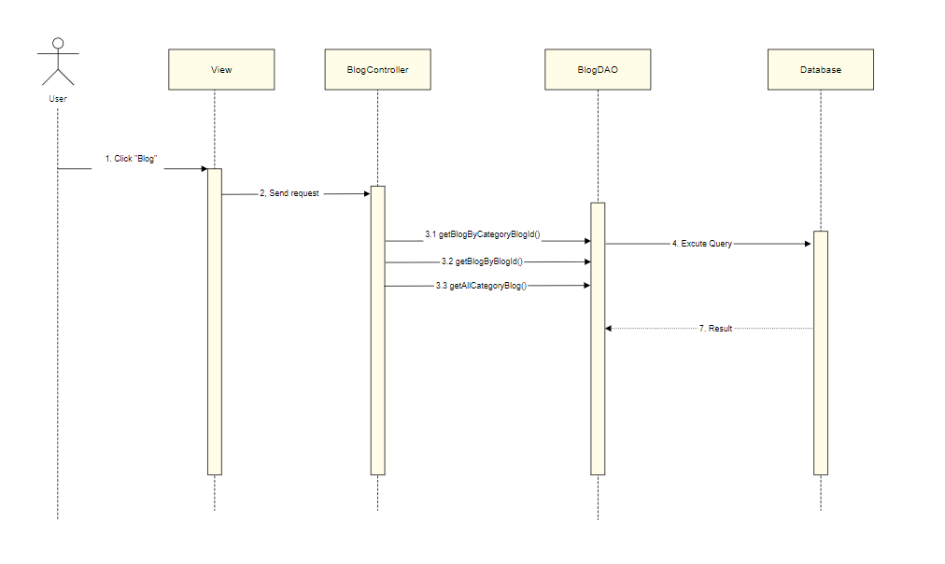

### d. Database queries

Select * from Blog

Select * from Blog where categoryBlog_id = ?

Select * from Blog where blog_id = ?

# III. Database Design

## 1. Database Schema

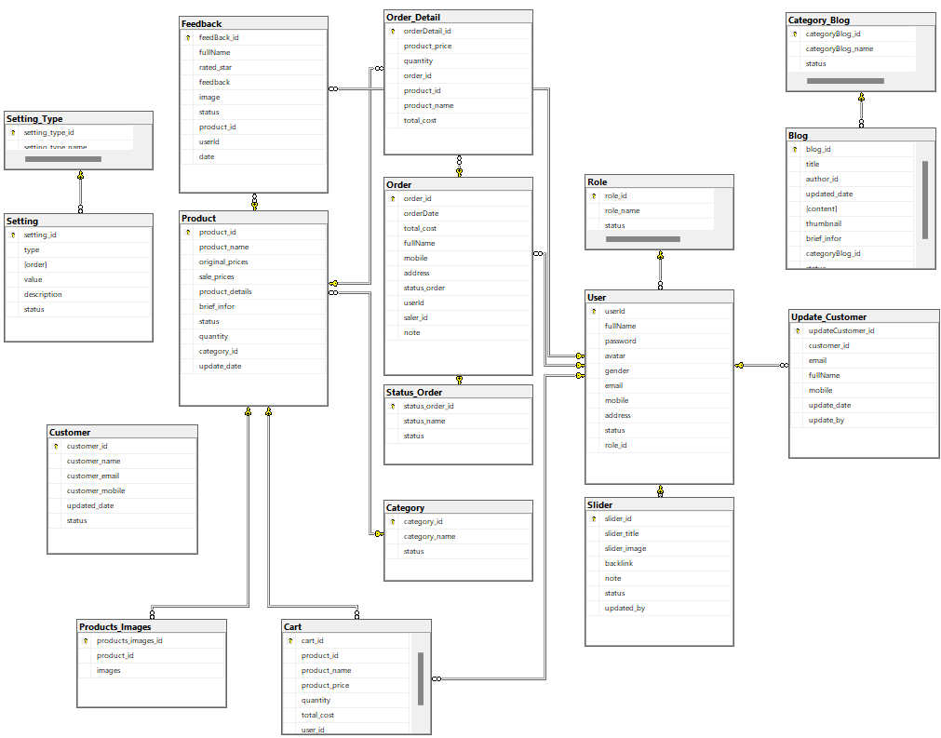

## 2. Table Description

| **#** | **Table** | **Description** |
| --- | --- | --- |
| 1 | User | userId int ,  fullName nvarchar(50),  password varchar(50),  avatar varbinary(max),  gender bit,  email varchar(50),  mobile varchar(50),  role_id int,  [address] nvarchar(255),  [status] nvarchar(50)  **Primary key: userId**  **Foreign key: role_id** |
| 2 | Role | role_id int,  role_name varchar(50)  **Primary key: role_id** |
| 3 | Category | category_id int,  category_name nvarchar(50)  Status bit  **Primary key: category_id** |
| 4 | Product | product_id,  product_name nvarchar(255),  category_id int,  brief_infor  original_prices float,  sale_prices float,  product_details nvarchar(max),  quantity int,  Status nvarchar(50)  **Primary key: product_id**  **Foreign key: category_id** |
| 5 | Product_Images | Product_Images_id int,  Product_id int,  images varchar(max)  **Primary key: statusOrder_id**  **Foreign key: Product_id** |
| 6 | Order | order_id int,  fullName nvarchar(50),  email varchar(50),  mobile varchar(50),  Address nvarchar(255),  orderDate date,  total_cost float,  statusOrder_id int,  user_id int  **Primary key: order_id**  **Foreign key: user_id** |
| 7 | orderDetail | orderDetail_id int,  product_id int,  prices float,  quantity int,  order_id int  **Primary key: orderDetail_id**  **Foreign key:product_id int_id** |
| 8 | Feedback | feedBack_id int,  fullName nvarchar(50),  rated_star float,  feedback nvarchar(max),  image_status varbinary(max),  Status bit,  product_id int,  userId int,  **Primary key: feedBack_id**  **Foreign key: product_id, userId** |
| 9 | categoryBlog | categoryBlog_id int,  categoryBlog_name nvarchar(50),  Status int  **Primary key: categoryBlog_id** |
| 10 | Blog | blog_id int,  title nvarchar(50),  author_id int,  updated_date date,  content text,  Thumbnail text,  Brief_infor nvarchar(255)  categoryBlog_id int,  **Primary key: blog_id**  **Foreign key: author_id, categoryBlog_id** |
| 11 | UpdateCustomer | udateCustomer_id int,  email varchar(50),  fullName nvarchar(50),  Gender bit,  mobile varchar(50),  Address nvarchar(255)  updated_date date,  updated_by int,  **Primary key: udateCustomer_id**  **Foreign key: updated_by** |
| 12 | Slider | slider_id int,  slider_title nvarchar(50),  Slider_images text,  Backlink varchar(max),  Note nvarchar(50),  Status int,  update_by int,  **Primary key: slider_id**  **Foreign key: update_by** |
| 13 | Status_Order | status_order_id int,  status_name nvarchar(50),  Status bit,  **Primary key: status_order_id** |
| 14 | Customer | customer_id int,  customer_name nvarchar(50),  customer_email varchar(50),  customer_mobile varchar(50),  updated_date date,  status bit  **Primary key: customer_id** |
| 15 | Cart | cart_id int,  product_id int,  product_name nvarchar(255),  product_price int,  quantity int,  total_cost int,  user_id int  **Primary key: cart_id**  **Foreign key: product_id, user_id** |
| 16 | Setting | setting_id int,  Type int,  [order] int,  value nvarchar(50),  description nvarchar(50),  Status bit  **Primary key: setting_id**  **Foreign key: type** |
| 17 | Setting_Type | Setting_type_id int,  Setting_type_name nvarchar(50)  **Primary key: Setting_type_id** |